**30%**

**“img”:””**

[](https://www.bookswagon.com/book/untitled-332595-jeff-kinney-author/9780241583166)

**Diary of a Wimpy Kid: Hot Mess (Book 19)**Jeff Kinney

No Review Yet

**₹455**

**39%**

[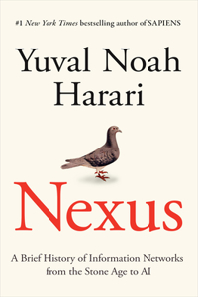](https://www.bookswagon.com/book/untitled-4223-yuval-noah-harari/9780593734223)

**Nexus**Yuval Noah Harari

No Review Yet

**₹1,879**

**43%**

[](https://www.bookswagon.com/book/war-bob-woodward/9781668052273)

**War**Bob Woodward

No Review Yet

**₹569**

**32%**

[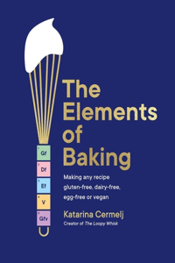](https://www.bookswagon.com/book/elements-baking-katarina-cermelj/9781399712897)

**The Elements of Baking**Katarina Cermelj

No Review Yet

**₹1,666**

**32%**

[](https://www.bookswagon.com/book/ottolenghi-comfort-yotam-ottolenghi-helen/9781785038914)

**Ottolenghi COMFORT**Yotam Ottolenghi

No Review Yet

**₹1,359**

**40%**

[](https://www.bookswagon.com/book/greatest-short-stories-dostoevsky-fyodor/9789358567021)

**Greatest Short Stories of Dostoevsky**Fyodor Dostoevsky

No Review Yet

**₹119**

[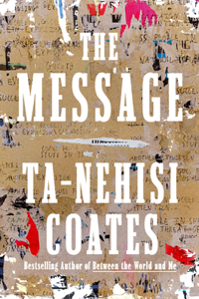](https://www.bookswagon.com/book/message-tanehisi-coates/9780593230381)

**Message The**Ta-Nehisi Coates

No Review Yet

**₹1,221**

**30%**

[](https://www.bookswagon.com/book/percy-jackson-olympians-rick-riordan/9780241691700)

**Percy Jackson and the Olympians: Wrath of the Triple Goddess**Rick Riordan

No Review Yet

**₹489**

**27%**

[](https://www.bookswagon.com/book/untitled-fsg-fiction-f24-sally/9780374602635)

**Intermezzo**Sally Rooney

No Review Yet

**₹1,863**

**23%**

[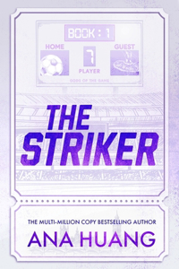](https://www.bookswagon.com/book/untitled-ana-huang-ana-huang/9780349442259)

**The Striker**Ana Huang

No Review Yet

**₹615**

**16%**

[](https://www.bookswagon.com/book/harry-potter-books-13-boxed/9781546130192)

**Harry Potter Books 1-3 Boxed Set (Minalima Editions)**J K ROWLING

No Review Yet

**₹8,573**

**24%**

[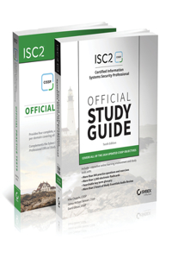](https://www.bookswagon.com/book/isc2-cissp-certified-information-systems/9781394258413)

**ISC2 CISSP Certified Information Systems Security Professional Official Study Guide & Practice Tests Bundle**Mike Chapple

No Review Yet

**₹6,281**

**25%**

[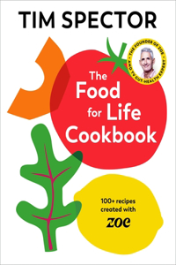](https://www.bookswagon.com/book/food-life-cookbook-tim-spector/9781787335233)

**The Food For Life Cookbook**Tim Spector

No Review Yet

**₹2,279**

**31%**

[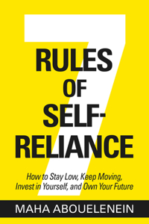](https://www.bookswagon.com/book/7-rules-selfreliance-maha-abouelenein/9781401978662)

**7 Rules of Self-Reliance**Maha Abouelenein

No Review Yet

**₹1,639**

**31%**

[](https://www.bookswagon.com/book/adventure-classics-collection/9789358569155)

**Adventure Classics Collection**

No Review Yet

**₹620**

**41%**

[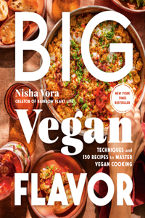](https://www.bookswagon.com/book/big-vegan-flavor-nisha-vora/9780593328934)

**Big Vegan Flavor**Nisha Vora

No Review Yet

**₹1,651**

**31%**

[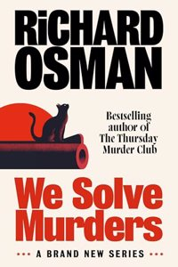](https://www.bookswagon.com/book/we-solve-murders-richard-osman/9780241608371)

**We Solve Murders**Richard Osman

No Review Yet

**₹620**

**32%**

[](https://www.bookswagon.com/book/turkuaz-kitchen-b%C3%ABtul-bet%C3%BCl-tun%C3%A7/9781984862228)

**Turkuaz Kitchen**Bëtul Tunç

No Review Yet

**₹2,288**

**24%**

[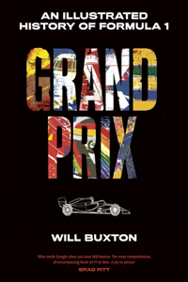](https://www.bookswagon.com/book/grand-prix--buxton/9780241712443)

**Grand Prix**Will Buxton

No Review Yet

**₹2,062**

**25%**

[](https://www.bookswagon.com/book/eat-like-a-girl-mindy/9781401979447)

**Eat Like a Girl**Mindy Pelz

No Review Yet

**₹1,980**

**41%**

[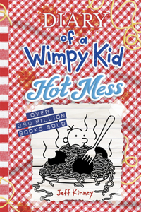](https://www.bookswagon.com/book/hot-mess-diary-a-wimpy/9781419766954)

**Hot Mess (Diary of a Wimpy Kid Book 19)**Jeff Kinney

No Review Yet

**₹973**

**28%**

[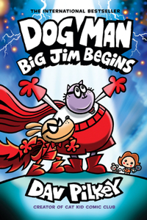](https://www.bookswagon.com/book/dog-man-dav-pilkey/9781338896459)

**Big Jim Begins: A Graphic Novel**Dav Pilkey

No Review Yet

**₹1,029**

**35%**

[](https://www.bookswagon.com/book/financially-smart-nita-menezes/9789360452223)

**Be Financially Smart**Nita Menezes

No Review Yet

**₹259**

**30%**

[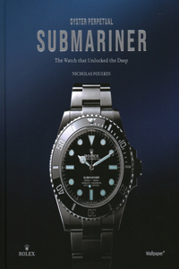](https://www.bookswagon.com/book/oyster-perpetual-submariner-nicholas-foulkes/9781805218937)

**Oyster Perpetual Submariner**Nicholas Foulkes

No Review Yet

**₹7,613**

**28%**

[](https://www.bookswagon.com/book/boyfriend-freida-mcfadden/9781728296227)

**Boyfriend**Freida McFadden

No Review Yet

**₹1,140**

**24%**

[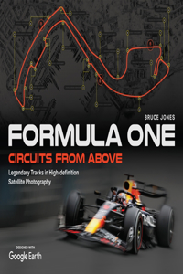](https://www.bookswagon.com/book/formula-one-circuits-from-above/9781035416707)

**Formula One Circuits From Above**Bruce Jones

No Review Yet

**₹2,474**

**37%**

[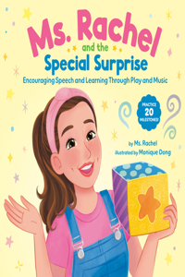](https://www.bookswagon.com/book/ms-rachel-special-surprise-monique/9780593811269)

**Ms. Rachel and the Special Surprise: Encouraging Speech and Learning Through Play and Music**Monique Dong

No Review Yet

**₹1,275**

**18%**

[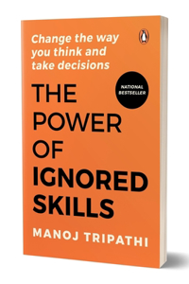](https://www.bookswagon.com/book/power-ignored-skills-manoj-tripathi/9780143470397)

**Power of Ignored Skills**Manoj Tripathi

No Review Yet

**₹205**

**31%**

[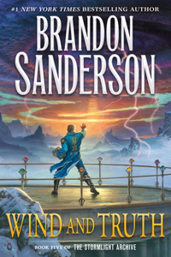](https://www.bookswagon.com/book/wind-truth-brandon-sanderson/9781250319180)

**Wind and Truth**Brandon Sanderson

No Review Yet

**₹2,307**

**31%**

[](https://www.bookswagon.com/book/patriot-alexei-navalny/9780593320969)

**Patriot**Alexei Navalny

No Review Yet

**₹2,125**

**20%**

[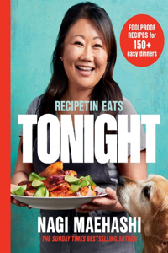](https://www.bookswagon.com/book/recipetin-eats-nagi-maehashi/9781035051861)

**RecipeTin Eats: Tonight**Nagi Maehashi

No Review Yet

**₹2,288**

**41%**

[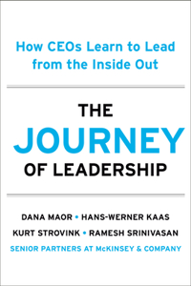](https://www.bookswagon.com/book/journey-leadership-ramesh-srinivasan-hanswerner/9780593714218)

**Journey of Leadership**Ramesh Srinivasan

No Review Yet

**₹1,661**

**24%**

[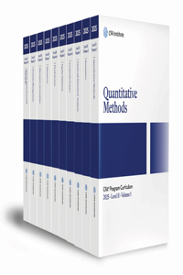](https://www.bookswagon.com/book/2025-cfa-program-curriculum-level/9781961409200)

**2025 Cfa Program Curriculum Level II Box Set**CFA INSTITUTE

No Review Yet

**₹16,530**

**36%**

[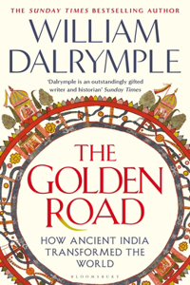](https://www.bookswagon.com/book/golden-road-william-dalrymple/9781408864418)

**The Golden Road**William Dalrymple

No Review Yet

**₹639**

**31%**

[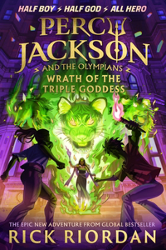](https://www.bookswagon.com/book/percy-jackson-olympians-rick-riordan/9780241691694)

**Percy Jackson and the Olympians: Wrath of the Triple Goddess**Rick Riordan

No Review Yet

**₹689**

**30%**

[](https://www.bookswagon.com/book/sweet-tooth-sarah-fennel/9780593581995)

**Sweet Tooth**Sarah Fennel

No Review Yet

**₹2,279**

**27%**

[](https://www.bookswagon.com/book/wild-eyes-elsie-silver/9780349441641)

**Wild Eyes**Elsie Silver

No Review Yet

**₹802**

**24%**

[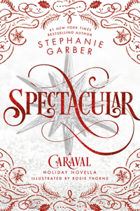](https://www.bookswagon.com/book/spectacular-stephanie-garber-rosie-fowinkle/9781250370990)

**Spectacular**Stephanie Garber

No Review Yet

**₹869**

**25%**

[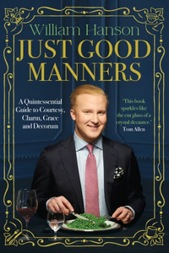](https://www.bookswagon.com/book/just-good-manners-william-hanson/9781529939958)

**Just Good Manners**William Hanson

No Review Yet

**₹1,650**

**10%**

[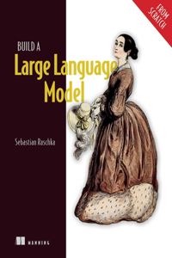](https://www.bookswagon.com/book/build-a-large-language-model/9781633437166)

**Build a Large Language Model (From Scratch)**Sebastian Raschka

No Review Yet

**₹4,752**

**37%**

[](https://www.bookswagon.com/book/untitled-rhbfyr-1252-monique-dong/9780593811252)

**Ms. Rachel and the Special Surprise: Encouraging Speech and Learning Through Play and Music**Monique Dong

No Review Yet

**₹1,109**

**28%**

[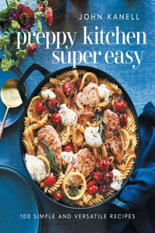](https://www.bookswagon.com/book/preppy-kitchen-super-easy-john/9781668026823)

**Preppy Kitchen Super Easy**John Kanell

No Review Yet

**₹2,218**

**46%**

[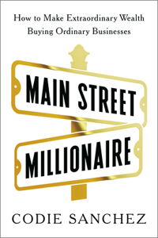](https://www.bookswagon.com/book/main-street-millionaire-codie-sanchez/9780593718612)

**Main Street Millionaire**Codie Sanchez

No Review Yet

**₹1,426**

**27%**

[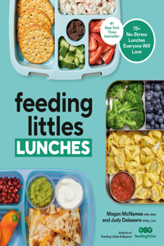](https://www.bookswagon.com/book/feeding-littles-lunches-megan-mcnamee/9780593797457)

**Feeding Littles Lunches**Megan McNamee

No Review Yet

**₹1,734**

**38%**

[](https://www.bookswagon.com/book/untitled-amulet-fantasy-series-deluxe/9781419778797)

**Lightlark: Collector’s Edition (The Lightlark Saga Book 1)**Abrams Books

No Review Yet

**₹1,888**

**27%**

[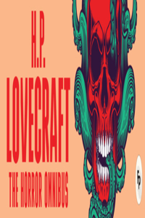](https://www.bookswagon.com/book/horror-omnibus-hp-lovecraft/9789358565232)

**Horror Omnibus**HP Lovecraft

No Review Yet

**₹364**

**32%**

[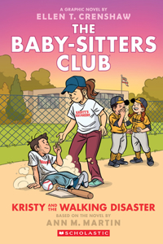](https://www.bookswagon.com/book/kristy-walking-disaster-m-ann/9781338835557)

**Kristy and the Walking Disaster: A Graphic Novel (the Baby-Sitters Club #16)**Ann M. Martin

No Review Yet

**₹822**

**42%**

[](https://www.bookswagon.com/book/supremacy-parmy-olson/9781035038237)

**Supremacy**Parmy Olson

No Review Yet

**₹521**

**17%**

[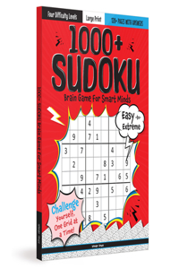](https://www.bookswagon.com/book/1000-sudoku-brain-games-smart/9789358565072)

**1000 + Sudoku Brain Games for Smart Minds**

No Review Yet

**₹207**

**33%**

[](https://www.bookswagon.com/book/return-caraval-complete-collection-box/9781399741941)

**The Return To Caraval Complete Collection Box Set**

No Review Yet

**₹5,158**

**23%**

[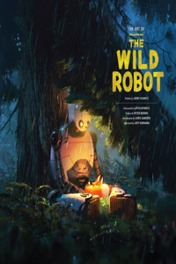](https://www.bookswagon.com/book/art-dreamworks-wild-robot-peter/9781419773280)

**The Art of DreamWorks The Wild Robot**Peter Brown

No Review Yet

**₹2,965**

**37%**

[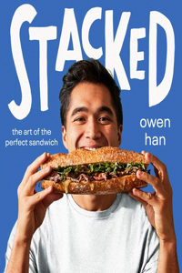](https://www.bookswagon.com/book/stacked-owen-han/9780063330658)

**Stacked**Owen Han

No Review Yet

**₹1,663**

**26%**

[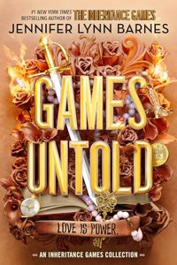](https://www.bookswagon.com/book/games-untold-barnes-jennifer-lynn/9780241684320)

**Games Untold**Jennifer Lynn Barnes

No Review Yet

**₹1,043**

**31%**

[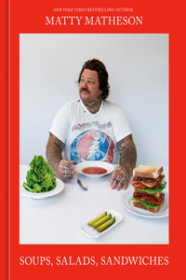](https://www.bookswagon.com/book/matty-matheson-matty-matheson/9781984862150)

**Soups Salads Sandwiches**Matty Matheson

No Review Yet

**₹2,353**

**28%**

[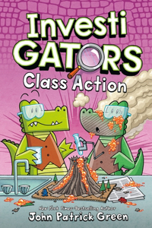](https://www.bookswagon.com/book/investigators-john-patrick-green/9781250849908)

**Investigators: Class Action**John Patrick Green

No Review Yet

**₹824**

[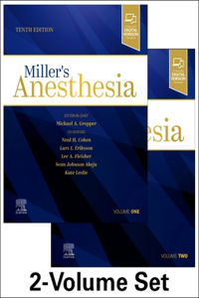](https://www.bookswagon.com/book/millers-anesthesia-2volume-set-lee/9780323935920)

**Miller's Anesthesia, 2-Volume Set**Lee A Fleisher

No Review Yet

**₹25,084**

[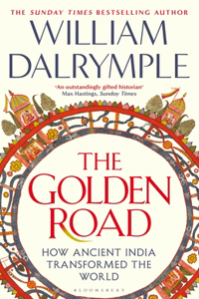](https://www.bookswagon.com/book/golden-road-william-dalrymple/9781408864425)

**The Golden Road**William Dalrymple

No Review Yet

**₹1,499**

**39%**

[](https://www.bookswagon.com/book/somewhere-beyond-sea-tj-klune/9781035055234)

**Somewhere Beyond the Sea**Tj Klune

No Review Yet

**₹365**

**20%**

[](https://www.bookswagon.com/book/start-a-pediatrician%C3%A2s-prescription-healthy/9789358863925)

**Healthy Start | A Pediatricianâ€™s Prescription for Healthy Babies and Happy Mothers | Dr. Imran Patel | Invincible**Dr. Imran Patel

No Review Yet

**₹239**

**20%**

[](https://www.bookswagon.com/book/start-a-pediatrician%C3%A2s-prescription-healthy/9789358863925)

**Healthy Start | A Pediatricianâ€™s Prescription for Healthy Babies and Happy Mothers | Dr. Imran Patel | Invincible**Dr. Imran Patel

No Review Yet

**₹239**

**25%**

[](https://www.bookswagon.com/book/ambitious-kitchen-cookbook-monique-volz/9780593581650)

**The Ambitious Kitchen Cookbook**Monique Volz

No Review Yet

**₹1,124**

**35%**

[](https://www.bookswagon.com/book/bluebell-bookstore-laurie-gilmore/9780008641580)

**The Cinnamon Bun Book Store**Laurie Gilmore

No Review Yet

**₹324**

**43%**

[](https://www.bookswagon.com/book/untitled-book-a-nonymous/9781510782693)

**Melania**A. Nonymous

No Review Yet

**₹1,823**

**48%**

[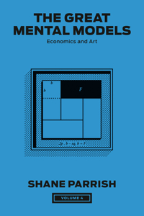](https://www.bookswagon.com/book/great-mental-models-volume-4/9780593720004)

**Great Mental Models, Volume 4**Shane Parrish

No Review Yet

**₹1,583**

**32%**

[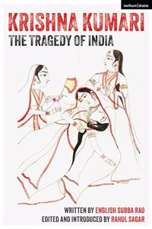](https://www.bookswagon.com/book/krishna-kumari-rahul-sagar-english/9789361313011)

**Krishna Kumari: The Tragedy of India**Rahul Sagar

No Review Yet

**₹339**

**22%**

[](https://www.bookswagon.com/book/not-sure-who-needs-hear/9780593796207)

**Not Sure Who Needs to Hear This, But . . .: We the Urban**Willie Greene

No Review Yet

**₹1,167**

**35%**

[](https://www.bookswagon.com/book/women-living-deliciously-florence-given/9781914240485)

**Women Living Deliciously**Florence Given

No Review Yet

**₹1,039**

**40%**

[](https://www.bookswagon.com/book/nothing-like-movies-lynn-painter/9781665947138)

**Nothing Like the Movies**Lynn Painter

No Review Yet

**₹1,319**

**30%**

[](https://www.bookswagon.com/book/batman-viktor-bogdanovic-alisson-borges/9781779529503)

**Batman: The Arkham Saga Omnibus**Viktor Bogdanovic

No Review Yet

**₹9,240**

[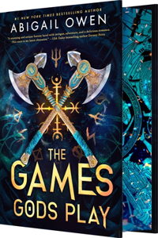](https://www.bookswagon.com/book/games-gods-play-abigail-owen/9781649376565)

**Games Gods Play (Deluxe Limited Edition)**Abigail Owen

No Review Yet

**₹2,687**

**31%**

[](https://www.bookswagon.com/book/untitled-9895/9780593799895)

**Be Ready When the Luck Happens**Ina Garten

No Review Yet

**₹2,064**

**38%**

[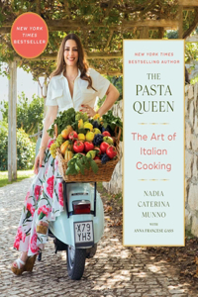](https://www.bookswagon.com/book/pasta-queen-nadia-caterina-munno/9781668047286)

**The Pasta Queen: The Art of Italian Cooking**Anna Francese Gass

No Review Yet

**₹1,773**

**43%**

[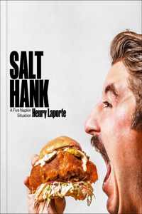](https://www.bookswagon.com/book/salt-hank-henry-laporte/9781668025482)

**Salt Hank**Henry Laporte

No Review Yet

**₹1,756**

**32%**

[](https://www.bookswagon.com/book/belladonna-collection-adalyn-grace/9780316582490)

**Belladonna Collection**Adalyn Grace

No Review Yet

**₹3,590**

**37%**

[](https://www.bookswagon.com/book/untitled-gwal-anonymous-gwal/9781250319906)

**Freedom**Angela Merkel

No Review Yet

**₹2,218**

**40%**

[](https://www.bookswagon.com/book/one-piece-vol-106-eiichiro/9781974745869)

**One Piece, Vol. 106**Eiichiro Oda

No Review Yet

**₹634**

**27%**

[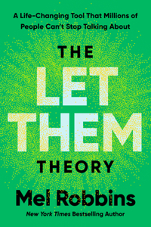](https://www.bookswagon.com/book/let-them-theory-robbins-mel/9781401971366)

**Let Them Theory**Mel Robbins

No Review Yet

**₹1,927**

**25%**

[](https://www.bookswagon.com/book/we-who-wrestle-god-jordan/9780241619612)

**We Who Wrestle With God**Jordan B. Peterson

No Review Yet

**₹2,441**

**43%**

[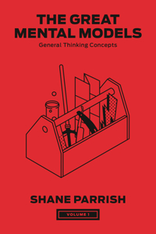](https://www.bookswagon.com/book/great-mental-models-volume-1/9780593719978)

**Great Mental Models, Volume 1**Shane Parrish

No Review Yet

**₹1,505**

**39%**

[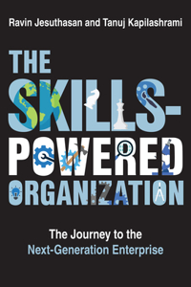](https://www.bookswagon.com/book/skillspowered-organization-ravin-jesuthasan-tanuj/9780262049238)

**Skills-Powered Organization**Ravin Jesuthasan

No Review Yet

**₹2,013**

**35%**

[](https://www.bookswagon.com/book/christmas-tree-farm-laurie-gilmore/9780008610746)

**The Christmas Tree Farm**Laurie Gilmore

No Review Yet

**₹324**

**26%**

[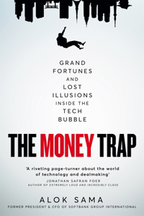](https://www.bookswagon.com/book/money-trap-alok-sama/9781035049349)

**The Money Trap**Alok Sama

No Review Yet

**₹1,365**

**22%**

[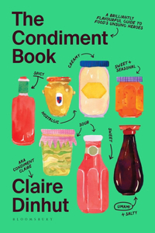](https://www.bookswagon.com/book/condiment-book-claire-dinhut/9781526669780)

**The Condiment Book**Claire Dinhut

No Review Yet

**₹1,269**

**32%**

[](https://www.bookswagon.com/book/disruptor-lionel-barber/9780241582725)

**Gambling Man**Lionel Barber

No Review Yet

**₹1,155**

**26%**

[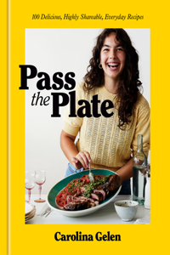](https://www.bookswagon.com/book/pass-plate-carolina-gelen/9780593581872)

**Pass the Plate**Carolina Gelen

No Review Yet

**₹2,279**

**32%**

[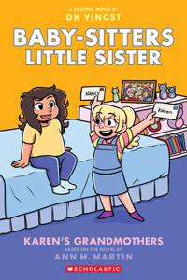](https://www.bookswagon.com/book/karens-grandmothers-ann-m-martin/9781339005034)

**Karen's Grandmothers: A Graphic Novel (Baby-Sitters Little Sister #9)**Ann M. Martin

No Review Yet

**₹822**

**32%**

[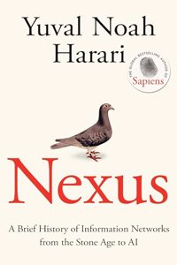](https://www.bookswagon.com/book/nexus-yuval-noah-harari/9781911717096)

**Nexus**Yuval Noah Harari

No Review Yet

**₹747**

**51%**

[](https://www.bookswagon.com/book/unti-memoir-anon9780063387263/9780063387263)

**Unleashed**Boris Johnson

No Review Yet

**₹1,705**

**31%**

[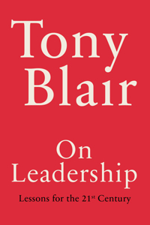](https://www.bookswagon.com/book/leadership-tony-blair/9780593799796)

**On Leadership**Tony Blair

No Review Yet

**₹1,943**

**31%**

[](https://www.bookswagon.com/book/we-who-wrestle-god-peterson/9780241619636)

**We Who Wrestle With God**Jordan B. Peterson

No Review Yet

**₹758**

**33%**

[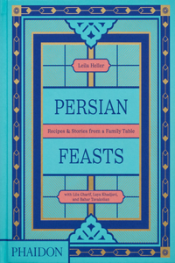](https://www.bookswagon.com/book/persian-feasts-laya-khadjavi-leila/9781838667528)

**Persian Feasts**Laya Khadjavi

No Review Yet

**₹2,912**

**25%**

[](https://www.bookswagon.com/book/martha-martha-stewart/9780593139202)

**Martha: The Cookbook**Martha Stewart

No Review Yet

**₹2,640**

**28%**

[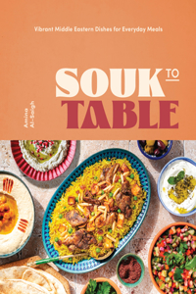](https://www.bookswagon.com/book/souk-table-amina-alsaigh/9781631069765)

**Souk to Table**Amina Al-Saigh

No Review Yet

**₹1,260**

**27%**

[](https://www.bookswagon.com/book/life-svalbard-cecilia-blomdahl/9780744095098)

**Life on Svalbard**Cecilia Blomdahl

No Review Yet

**₹2,056**

**26%**

[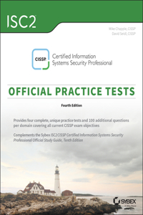](https://www.bookswagon.com/book/isc2-cissp-certified-information-systems/9781394255078)

**Isc2 Cissp Certified Information Systems Security Professional Official Practice Tests**David Seidl

No Review Yet

**₹2,704**

**17%**

[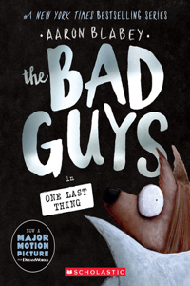](https://www.bookswagon.com/book/in-one-last-thing-the/9781546111801)

**Bad Guys in One Last Thing (the Bad Guys #20)**Aaron Blabey

No Review Yet

**₹511**

**25%**

[](https://www.bookswagon.com/book/warhammer-40000-ultimate-guide-gavin/9780241661314)

**Warhammer 40,000 The Ultimate Guide**Gavin Thorpe

No Review Yet

**₹2,888**

**24%**

[](https://www.bookswagon.com/book/divine-comedy-dante-alighieri/9789358565140)

**Divine Comedy**Dante Alighieri

No Review Yet

**₹303**

**36%**

[](https://www.bookswagon.com/book/house-war-sir-simon-mayall/9781472864338)

**House of War**Simon Mayall

No Review Yet

**₹1,971**

**35%**

[](https://www.bookswagon.com/book/murderous-plot-sue-minix/9780008659851)

**Murderous Plot**Sue Minix

No Review Yet

**₹324**

**58%**

[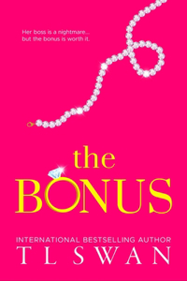](https://www.bookswagon.com/book/bonus-t-l-swan/9780975663806)

**Bonus**T L Swan

No Review Yet

**₹702**

**17%**

[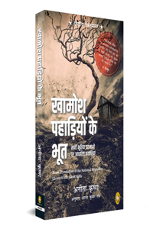](https://www.bookswagon.com/book/ghost-silent-hills-anita-krishan/9789358567533)

**Ghost of Silent Hills**ANITA KRISHAN

No Review Yet

**₹207**

**32%**

[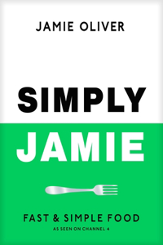](https://www.bookswagon.com/book/simply-jamie-jamie-oliver/9780241657805)

**Simply Jamie**Jamie Oliver

No Review Yet

**₹1,359**

**20%**

[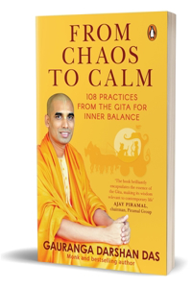](https://www.bookswagon.com/book/from-chaos-calm-gauranga-darshan/9780143463610)

**From Chaos to Calm**Gauranga Darshan Das

No Review Yet

**₹239**

**38%**

[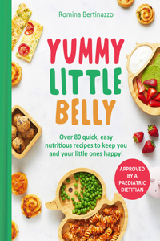](https://www.bookswagon.com/book/yummy-little-belly-romina-bertinazzo/9780008700164)

**Yummy Little Belly**Romina Bertinazzo

No Review Yet

**₹1,473**

**41%**

[](https://www.bookswagon.com/book/jujutsu-kaisen-vol-23-gege/9781974746293)

**Jujutsu Kaisen, Vol. 23**Gege Akutami

No Review Yet

**₹623**

**29%**

[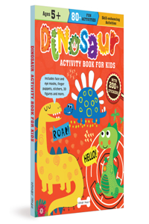](https://www.bookswagon.com/book/dinosaur-activity-book-kids/9789358563566)

**Dinosaur Activity Book for Kids**

No Review Yet

**₹425**

**28%**

[](https://www.bookswagon.com/book/stop-lying-yourself-simon-gilham/9781529939194)

**Stop Lying to Yourself**Simon Gilham

No Review Yet

**₹396**

**35%**

[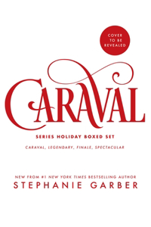](https://www.bookswagon.com/book/caraval-series-holiday-boxed-set/9781250368881)

**Caraval Holiday Collection**Stephanie Garber

No Review Yet

**₹5,604**

**27%**

[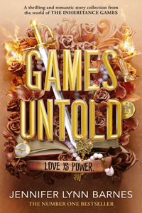](https://www.bookswagon.com/book/games-untold-jennifer-lynn-barnes/9780241684344)

**Games Untold**Jennifer Lynn Barnes

No Review Yet

**₹1,204**

**24%**

[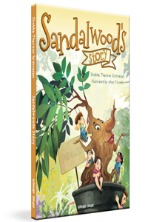](https://www.bookswagon.com/book/sandalwood%C3%A2s-story-ishan-trivedi-shobha/9789358568394)

**Sandalwood's Story**Ishan Trivedi

No Review Yet

**₹303**

**13%**

[](https://www.bookswagon.com/book/abdullah-al-saadi-abdullah-al/9786148035685)

**Abdullah Al Saadi: Sites of Memory, Sites of Amnesia**Tarek Abou El Fetouh

No Review Yet

**₹3,062**

**37%**

[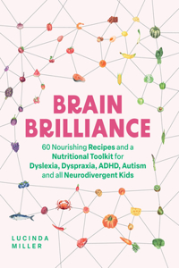](https://www.bookswagon.com/book/brain-brilliance-lucinda-miller/9781837831975)

**Brain Brilliance**Lucinda Miller

No Review Yet

**₹1,864**

**29%**

[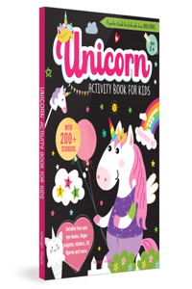](https://www.bookswagon.com/book/unicorn-activity-book-kids/9789358563559)

**Unicorn Activity Book for Kids**

No Review Yet

**₹425**

**32%**

[](https://www.bookswagon.com/book/art-uncertainty-david-spiegelhalter/9780241658628)

**The Art of Uncertainty**DAVID SPIEGELHALTER

No Review Yet

**₹1,019**

**25%**

[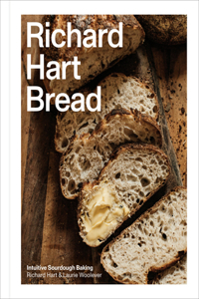](https://www.bookswagon.com/book/richard-hart-bread-richard-hart/9780593234297)

**Richard Hart Bread**Richard Hart

No Review Yet

**₹2,310**

**50%**

[](https://www.bookswagon.com/book/study-in-drowning-collectors-deluxe/9780063419414)

**Study in Drowning Collector's Deluxe Limited Edition**Ava Reid

No Review Yet

**₹957**

**24%**

[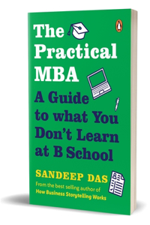](https://www.bookswagon.com/book/practical-mba-sandeep-das/9780143461197)

**Practical MBA**Sandeep Das

No Review Yet

**₹303**

**40%**

[](https://www.bookswagon.com/book/powerless-reckless-collection-boxed-set/9781665972765)

**Powerless & Reckless Collection (Boxed Set)**Lauren Roberts

No Review Yet

**₹2,771**

**38%**

[](https://www.bookswagon.com/book/chez-manon-manon-lagr%C3%A8ve/9781784889586)

**Chez Manon**Manon Lagreve

No Review Yet

**₹2,023**

**21%**

[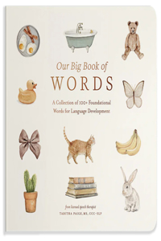](https://www.bookswagon.com/book/my-first-book-words-tabitha/9781958803875)

**Our Big Book of First Words**Tabitha Paige

No Review Yet

**₹1,040**

**28%**

[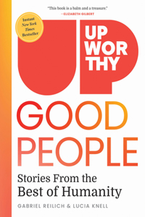](https://www.bookswagon.com/book/upworthy-good-people-gabriel-reilich/9781426223464)

**Upworthy - GOOD PEOPLE**Gabriel Reilich

No Review Yet

**₹1,774**

**38%**

[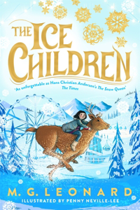](https://www.bookswagon.com/book/ice-children-m-g-leonard/9781035005949)

**The Ice Children**M. G. LEONARD

No Review Yet

**₹309**

**45%**

[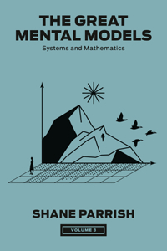](https://www.bookswagon.com/book/great-mental-models-volume-3/9780593719992)

**Great Mental Models, Volume 3**Shane Parrish

No Review Yet

**₹1,694**

**30%**

[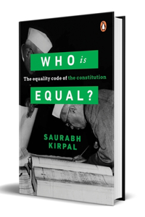](https://www.bookswagon.com/book/who-equal-saurabh-kirpal/9780670100149)

**Who Is Equal**Saurabh Kirpal

No Review Yet

**₹489**

**33%**

[](https://www.bookswagon.com/book/its-in-his-kiss-way/9780063383739)

**It's in His Kiss and on the Way to the Wedding: Bridgerton Collector's Edition**Julia Quinn

No Review Yet

**₹1,769**

**40%**

[](https://www.bookswagon.com/book/obsessed-johnny-sexton/9781844885206)

**Obsessed: The Autobiography**Johnny Sexton

No Review Yet

**₹2,036**

**48%**

[](https://www.bookswagon.com/book/untitled-memoir-lisa-marie-presley/9780593733875)

**From Here to the Great Unknown: Oprah's Book Club**Lisa Marie Presley

No Review Yet

**₹1,448**

**41%**

[](https://www.bookswagon.com/book/monica-la-diva-dolcegabbana-babeth/9788891841728)

**Monica La Diva Dolce&Gabbana**Babeth Djian

No Review Yet

**₹12,980**

**20%**

[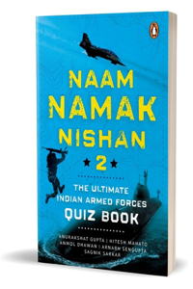](https://www.bookswagon.com/book/naam-namak-nishan-2-anurakshat/9780143466291)

**Naam, Namak, Nishan 2**Anurakshat Gupta

No Review Yet

**₹239**

**25%**

[](https://www.bookswagon.com/book/justine-cooks-justine-doiron/9780593582305)

**Justine Cooks: A Cookbook**Justine Doiron

No Review Yet

**₹1,124**

**19%**

[](https://www.bookswagon.com/book/art-memory-collecting-martina-calvi/9781784887773)

**The Art of Memory Collecting**Martina Calvi

No Review Yet

**₹1,782**

**26%**

[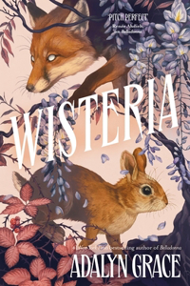](https://www.bookswagon.com/book/wisteria-adalyn-grace/9781399726085)

**Wisteria**Adalyn Grace

No Review Yet

**₹1,628**

**20%**

[](https://www.bookswagon.com/book/christmas-at-hogwarts-j-k/9781546129950)

**Christmas at Hogwarts**J K ROWLING

No Review Yet

**₹1,408**

**39%**

[](https://www.bookswagon.com/book/cats-world-hannah-shaw-andrew/9780593183113)

**Cats of the World**Hannah Shaw

No Review Yet

**₹1,158**

**32%**

[](https://www.bookswagon.com/book/city-its-uncertain-walls-haruki/9781787304475)

**The City and Its Uncertain Walls**Philip Gabriel

No Review Yet

**₹951**

**26%**

[](https://www.bookswagon.com/book/military-mindset-ant-middleton/9781399737005)

**Military Mindset: Lessons from the Battlefield**ANT MIDDLETON

No Review Yet

**₹1,766**

**29%**

[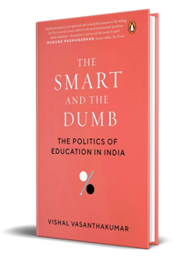](https://www.bookswagon.com/book/smart-dumb-vishal-vasanthakumar/9780670098637)

**Smart and the Dumb**Vishal Vasanthakumar

No Review Yet

**₹425**

**29%**

[](https://www.bookswagon.com/book/jonty-gentoo-hb-axel-scheffler/9780702329432)

**Jonty Gentoo - The Adventures of a Penguin**Axel Scheffler

No Review Yet

**₹1,015**

**24%**

[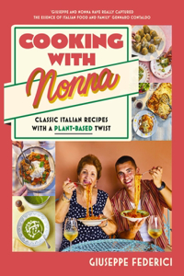](https://www.bookswagon.com/book/cooking-nonna-giuseppe-federici/9780241677988)

**Cooking with Nonna**Giuseppe Federici

No Review Yet

**₹2,062**

**38%**

[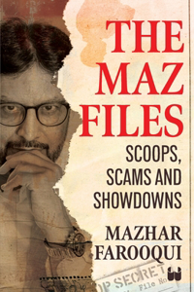](https://www.bookswagon.com/book/maz-files-farooqui-mazhar/9789360450373)

**The Maz Files**, Mazhar Farooqui

No Review Yet

**₹309**

**31%**

[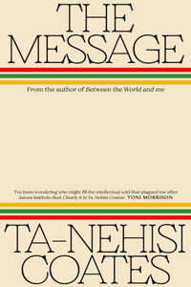](https://www.bookswagon.com/book/message-tanehisi-coates/9780241724194)

**The Message**Ta-Nehisi Coates

No Review Yet

**₹620**

**39%**

[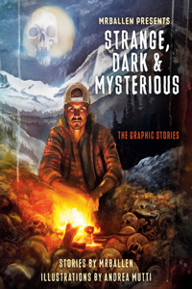](https://www.bookswagon.com/book/mrballen-presents-robert-venditti-andrea/9781984863430)

**MrBallen Presents: Strange, Dark & Mysterious**Robert Venditti

No Review Yet

**₹609**

**27%**

[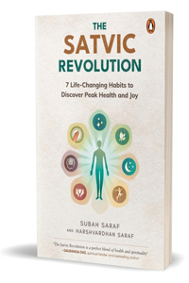](https://www.bookswagon.com/book/satvic-revolution-subah-harshvardhan-saraf/9780143460381)

**Satvic Revolution**Subah Saraf

No Review Yet

**₹364**

**19%**

[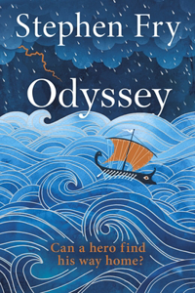](https://www.bookswagon.com/book/odyssey-stephen-fry/9780241486368)

**Odyssey**Stephen Fry

No Review Yet

**₹1,494**

**48%**

[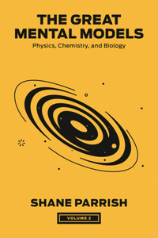](https://www.bookswagon.com/book/great-mental-models-volume-2/9780593719985)

**Great Mental Models, Volume 2**Shane Parrish

No Review Yet

**₹1,583**

**36%**

[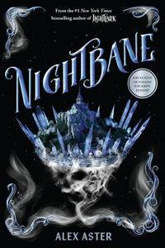](https://www.bookswagon.com/book/untitled-amulet-fantasy-series-book/9781419760914)

**Nightbane (The Lightlark Saga Book 2)**Abrams Books

No Review Yet

**₹780**

**25%**

[](https://www.bookswagon.com/book/spy-school-goes-wild-stuart/9781665934770)

**Spy School Goes Wild**Stuart Gibbs

No Review Yet

**₹1,254**

**36%**

[](https://www.bookswagon.com/book/stars-are-dying-chloe-c/9781250355669)

**Stars Are Dying**Chloe C. Penaranda

No Review Yet

**₹1,859**

**29%**

[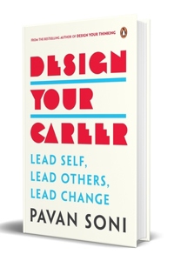](https://www.bookswagon.com/book/design-your-career-pavan-soni/9780143464938)

**Design Your Career**Pavan Soni

No Review Yet

**₹425**

**28%**

[](https://www.bookswagon.com/book/i-love-you-moon-back/9781664300545)

**I Love You to the Moon and Back**Amelia Hepworth

No Review Yet

**₹1,204**

**39%**

[](https://www.bookswagon.com/book/precipice-robert-harris/9780063248052)

**Precipice**Robert Harris

No Review Yet

**₹1,610**

**40%**

[](https://www.bookswagon.com/book/life-impossible-matt-haig/9780593489277)

**Life Impossible**Matt Haig

No Review Yet

**₹1,584**

**27%**

[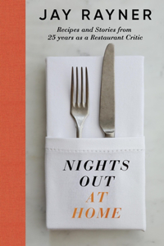](https://www.bookswagon.com/book/nights-out-at-home-jay/9780241639580)

**Nights Out At Home**Jay Rayner

No Review Yet

**₹1,094**

**35%**

[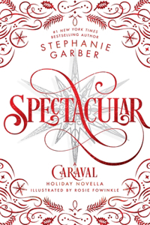](https://www.bookswagon.com/book/spectacular-stephanie-garber-rosie-fowinkle/9781250893406)

**Spectacular**Stephanie Garber

No Review Yet

**₹1,201**

**44%**

[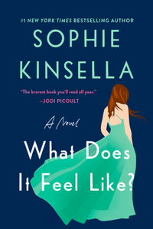](https://www.bookswagon.com/book/untitled-7569/9780593977569)

**What Does It Feel Like?**Sophie Kinsella

No Review Yet

**₹1,084**

**38%**

[](https://www.bookswagon.com/book/smart-building-advantage-matthew-jll/9781835498798)

**Smart Building Advantage**Matthew Marson

No Review Yet

**₹2,070**

**37%**

[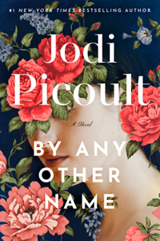](https://www.bookswagon.com/book/by-any-other-name-jodi/9780593497210)

**By Any Other Name**Jodi Picoult

No Review Yet

**₹1,663**

**28%**

[](https://www.bookswagon.com/book/before-we-forget-kindness-toshikazu/9781035046256)

**Before We Forget Kindness**Toshikazu Kawaguchi

No Review Yet

**₹859**

**40%**

[](https://www.bookswagon.com/book/intelligent-investor-3rd-ed-benjamin/9780063356726)

**Intelligent Investor, 3rd Ed.**Benjamin Graham

No Review Yet

**₹1,980**

**35%**

[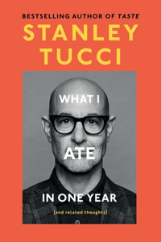](https://www.bookswagon.com/book/untitled-st/9781668055687)

**What I Ate in One Year**Stanley Tucci

No Review Yet

**₹2,002**

**24%**

[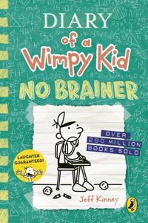](https://www.bookswagon.com/book/diary-wimpy-kid-jeff-kinney/9780241618158)

**Diary of a Wimpy Kid: No Brainer (Book 18)**Jeff Kinney

No Review Yet

**₹303**

**31%**

[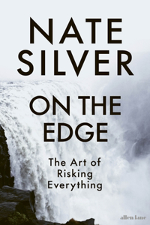](https://www.bookswagon.com/book/edge-nate-silver/9780241568521)

**On the Edge**Nate Silver

No Review Yet

**₹689**

**21%**

[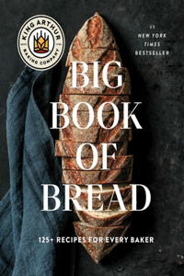](https://www.bookswagon.com/book/king-arthur-baking-company-big/9781668009741)

**King Arthur Baking Company Big Book of Bread**King Arthur Baking Company

No Review Yet

**₹3,128**

**26%**

[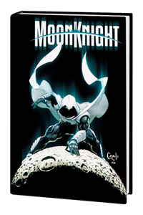](https://www.bookswagon.com/book/moon-knight-by-jed-mackay/9781302959487)

**Moon Knight by Jed Mackay Omnibus**Greg Capullo

No Review Yet

**₹7,325**

**33%**

[](https://www.bookswagon.com/book/magical-worlds-johanna-basford/9780143138358)

**Magical Worlds**Johanna Basford

No Review Yet

**₹1,061**

**40%**

[](https://www.bookswagon.com/book/beach-read-emily-henry/9780593817414)

**Beach Read**Emily Henry

No Review Yet

**₹1,848**

**32%**

[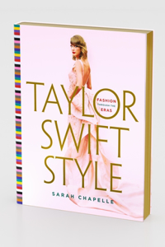](https://www.bookswagon.com/book/taylor-swift-style-sarah-chapelle/9781250906151)

**Taylor Swift Style**Sarah Chapelle

No Review Yet

**₹2,094**

**25%**

[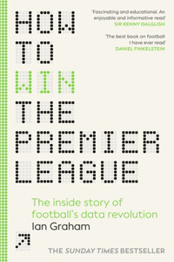](https://www.bookswagon.com/book/how-win-premier-league-ian/9781529934632)

**How to Win the Premier League**Ian Graham

No Review Yet

**₹1,790**

**27%**

[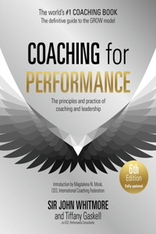](https://www.bookswagon.com/book/coaching-performance-6th-edition-john/9781399814904)

**Coaching for Performance, 6th edition**Sir John Whitmore

No Review Yet

**₹1,924**

**22%**

[](https://www.bookswagon.com/book/onyx-storm-rebecca-yarros/9780349437071)

**Onyx Storm**Rebecca Yarros

No Review Yet

**₹1,458**

**30%**

[](https://www.bookswagon.com/book/brief-history-present-hilal-ahmed/9780670094356)

**Brief History of the Present**Hilal Ahmed

No Review Yet

**₹489**

**31%**

[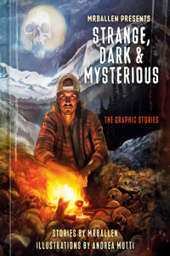](https://www.bookswagon.com/book/mrballen-presents-robert-venditti-andrea/9781984863423)

**MrBallen Presents: Strange, Dark & Mysterious**Robert Venditti

No Review Yet

**₹1,594**

**26%**

[](https://www.bookswagon.com/book/lottie-brookss-essential-guide-life/9780241647202)

**Lottie Brooks’s Essential Guide to Life**Katie Kirby

No Review Yet

**₹333**

**27%**

[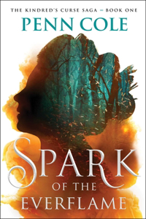](https://www.bookswagon.com/book/untitled-se--confirmed-atria/9781668085721)

**Spark of the Everflame**To Be Confirmed Atria

No Review Yet

**₹1,927**

**14%**

[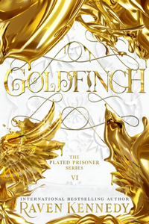](https://www.bookswagon.com/book/goldfinch-raven-kennedy/9780241695821)

**Goldfinch**Raven Kennedy

No Review Yet

**₹1,399**

**14%**

[](https://www.bookswagon.com/book/advent-calendar-book-collection-maria/9781836000815)

**Little People, Big Dreams: Advent Calendar Book Collection**Maria Isabel Sanchez Vegara

No Review Yet

**₹2,245**

**38%**

[](https://www.bookswagon.com/book/blue-lock-14-yusuke-nomura/9781646516711)

**Blue Lock 14**Yusuke Nomura

No Review Yet

**₹651**

**23%**

[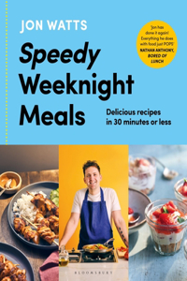](https://www.bookswagon.com/book/speedy-weeknight-meals-jon-watts/9781526677457)

**Speedy Weeknight Meals**Jon Watts

No Review Yet

**₹1,671**

**40%**

[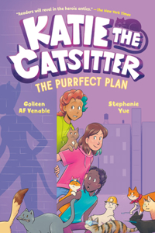](https://www.bookswagon.com/book/katie-catsitter-4-colleen-af/9780593570401)

**Katie the Catsitter 4: The Purrfect Plan**Colleen AF Venable

No Review Yet

**₹731**

**33%**

[](https://www.bookswagon.com/book/sir-phillip-love-he-was/9780063383661)

**To Sir Phillip, with Love and When He Was Wicked: Bridgerton Collector's Edition**Julia Quinn

No Review Yet

**₹1,769**

**23%**

[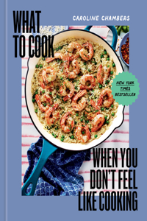](https://www.bookswagon.com/book/cook-you-dont-feel-like/9781454952718)

**What to Cook When You Don't Feel Like Cooking**Eva Kolenko

No Review Yet

**₹2,372**

**21%**

[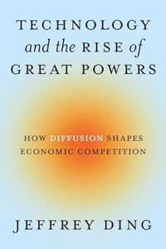](https://www.bookswagon.com/book/technology-rise-great-powers-jeffrey/9780691260341)

**Technology and the Rise of Great Powers**Jeffrey Ding

No Review Yet

**₹2,143**

**42%**

[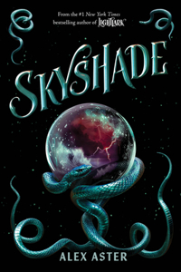](https://www.bookswagon.com/book/untitled-amulet-fantasy-series-book/9781419773785)

**Skyshade (The Lightlark Saga Book 3)**Abrams Books

No Review Yet

**₹1,161**

**27%**

[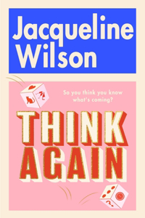](https://www.bookswagon.com/book/think-again-jacqueline-wilson/9780857506108)

**Think Again**Jacqueline Wilson

No Review Yet

**₹1,767**

**31%**

[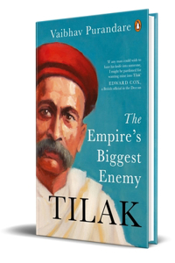](https://www.bookswagon.com/book/tilak-vaibhav-purandare/9780670095513)

**Tilak**Vaibhav Purandare

No Review Yet

**₹689**

**35%**

[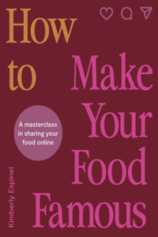](https://www.bookswagon.com/book/how-make-your-food-famous/9780711293816)

**How to Make Your Food Famous**Kimberly Espinel

No Review Yet

**₹1,131**

**22%**

[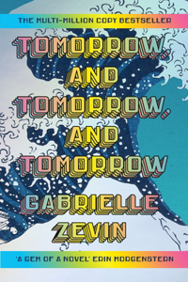](https://www.bookswagon.com/book/tomorrow-gabrielle-zevin/9781529944792)

**Tomorrow, and Tomorrow, and Tomorrow**Gabrielle Zevin

No Review Yet

**₹1,608**

**21%**

[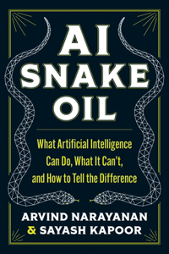](https://www.bookswagon.com/book/ai-snake-oil-arvind-narayanan/9780691249131)

**AI Snake Oil**Arvind Narayanan

No Review Yet

**₹1,735**

**8%**

[](https://www.bookswagon.com/book/sandra-boyntons-my-17month-20242025/9781524890148)

**Sandra Boynton's My Family Calendar 17-Month 2024-2025 Family Wall Calendar**Sandra Boynton

No Review Yet

**₹1,457**

**25%**

[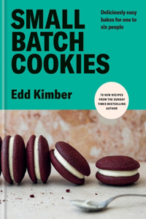](https://www.bookswagon.com/book/small-batch-cookies-edd-kimber/9781804191859)

**Small Batch Cookies**Edd Kimber

No Review Yet

**₹1,782**

**28%**

[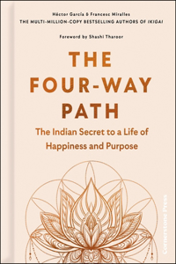](https://www.bookswagon.com/book/fourway-path-francesc-miralles-hector/9781529908206)

**The Four-Way Path**Francesc Miralles

No Review Yet

**₹1,171**

**39%**

[](https://www.bookswagon.com/book/lantern-lost-memories-sanaka-hiiragi/9781035023646)

**The Lantern of Lost Memories**Sanaka Hiiragi

No Review Yet

**₹365**

**26%**

[](https://www.bookswagon.com/book/imf1-matt-whyman/9781529916799)

**Inside Mercedes F1**Matt Whyman

No Review Yet

**₹1,766**

**28%**

[](https://www.bookswagon.com/book/warhammer-40000-ultimate-guide-gavin/9780593847114)

**Warhammer 40,000 the Ultimate Guide**Gavin Thorpe

No Review Yet

**₹2,851**

**27%**

[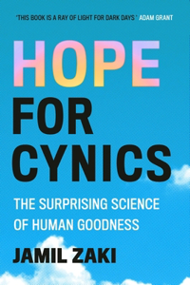](https://www.bookswagon.com/book/hopeful-sceptic-jamil-zaki/9781472148193)

**Hope for Cynics**Jamil Zaki

No Review Yet

**₹1,346**

**30%**

[](https://www.bookswagon.com/book/unleashed-boris-johnson/9780008618209)

**Unleashed**Boris Johnson

No Review Yet

**₹2,279**

**24%**

[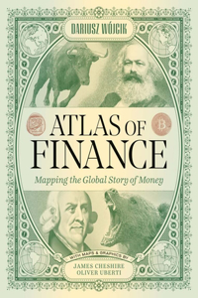](https://www.bookswagon.com/book/atlas-finance-dariusz-wojcik-michael/9780300253054)

**Atlas of Finance**Dariusz Wojcik

No Review Yet

**₹2,675**

**40%**

[](https://www.bookswagon.com/book/spy-x-family-vol-12/9781974747054)

**Spy x Family, Vol. 12**Tatsuya Endo

No Review Yet

**₹634**

**32%**

[](https://www.bookswagon.com/book/title-336983-al-pacino-author/9781529912623)

**Sonny Boy**Al Pacino

No Review Yet

**₹951**

**41%**

[](https://www.bookswagon.com/book/well-said-terry-szuplat/9780063337718)

**Say It Well**Terry Szuplat

No Review Yet

**₹1,661**

**32%**

[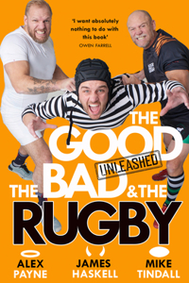](https://www.bookswagon.com/book/good-bad-rugby-unleashed-james/9780008712693)

**The Good, the Bad & the Rugby – Unleashed**James Haskell

No Review Yet

**₹1,646**

**34%**

[](https://www.bookswagon.com/book/autocracy-inc-anne-applebaum/9780385549936)

**Autocracy, Inc.**ANNE APPLEBAUM

No Review Yet

**₹1,568**

**34%**

[](https://www.bookswagon.com/book/money-couples-ramit-sethi/9781399728638)

**Money For Couples**Ramit Sethi

No Review Yet

**₹527**

**28%**

[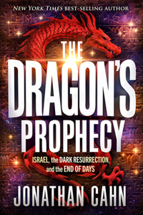](https://www.bookswagon.com/book/dragons-prophecy-jonathan-cahn/9781636413990)

**Dragon's Prophecy**Jonathan Cahn

No Review Yet

**₹1,837**

[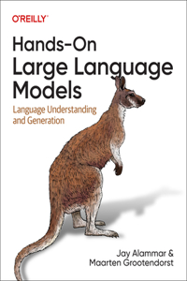](https://www.bookswagon.com/book/handson-large-language-models-jay/9781098150969)

**Hands-On Large Language Models**Jay Alammar

No Review Yet

**₹4,270**

**47%**

[](https://www.bookswagon.com/book/psychological-safety-hbr-emotional-intelligence/9781647829964)

**Psychological Safety**Amy C Edmondson

No Review Yet

**₹922**

**23%**

[](https://www.bookswagon.com/book/blood-over-bright-haven-m/9781529935516)

**Blood Over Bright Haven**M. L. Wang

No Review Yet

**₹1,587**

**29%**

[](https://www.bookswagon.com/book/zo%C3%AB-bakes-cookies-zo%C3%AB-fran%C3%A7ois/9781984860804)

**Zoe Bakes Cookies**Zoë François

No Review Yet

**₹1,953**

**52%**

[](https://www.bookswagon.com/book/poppy-war-collectors-edition-r/9780063413573)

**Poppy War Collector's Edition**R F Kuang

No Review Yet

**₹1,879**

**27%**

[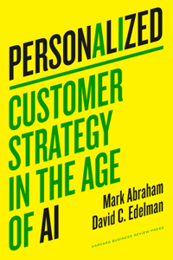](https://www.bookswagon.com/book/personalized-c-mark-abraham-david/9781647826277)

**Personalized**David C. Edelman

No Review Yet

**₹1,021**

**21%**

[](https://www.bookswagon.com/book/bulgari-aeterna-julia-watson-salvatore/9788891841742)

**Bulgari Aeterna**Julia Watson

No Review Yet

**₹6,529**

**31%**

[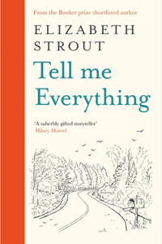](https://www.bookswagon.com/book/tell-me-everything-elizabeth-strout/9780241634356)

**Tell Me Everything**Elizabeth Strout

No Review Yet

**₹620**

**29%**

[](https://www.bookswagon.com/book/kelly-slater-eddie-vedder-kelly/9780847836079)

**Kelly Slater**Eddie Vedder

No Review Yet

**₹3,436**

**44%**

[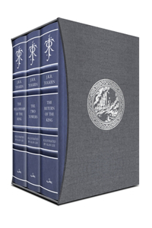](https://www.bookswagon.com/book/lord-rings-deluxe-illustrated-box/9780063392939)

**Lord of the Rings Deluxe Illustrated Box Set**J R R Tolkien

No Review Yet

**₹16,016**

**31%**

[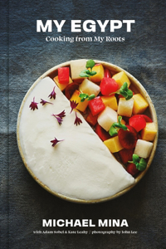](https://www.bookswagon.com/book/my-egypt-michael-mina/9780316429788)

**My Egypt**Michael Mina

No Review Yet

**₹2,429**

**23%**

[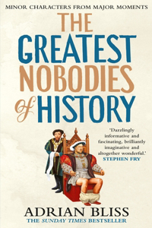](https://www.bookswagon.com/book/greatest-nobodies-history-adrian-bliss/9781529907452)

**The Greatest Nobodies of History**Adrian Bliss

No Review Yet

**₹1,587**

**47%**

[](https://www.bookswagon.com/book/match-day-annual-2025-match/9781785948381)

**Match of the Day Annual 2025**Match of the Day Magazine

No Review Yet

**₹830**

**35%**

[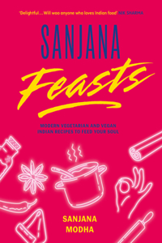](https://www.bookswagon.com/book/sanjana-feasts-sanjana-modha/9781800182967)

**Sanjana Feasts**Sanjana Modha

No Review Yet

**₹1,977**

**48%**

[](https://www.bookswagon.com/book/moneygpt-james-rickards/9780593718636)

**Moneygpt**James Rickards

No Review Yet

**₹1,312**

**31%**

[](https://www.bookswagon.com/book/100-unofficial-roblox-annual-2025/9780008616953)

**100% Unofficial Roblox Annual 2025**Farshore

No Review Yet

**₹620**

**26%**

[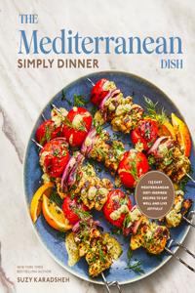](https://www.bookswagon.com/book/mediterranean-dish-suzy-karadsheh/9780593582121)

**Mediterranean Dish: Simply Dinner**Suzy Karadsheh

No Review Yet

**₹2,279**

**38%**

[](https://www.bookswagon.com/book/harry-potter-13-box-set/9781526680068)

**Harry Potter 1-3 Box Set: MinaLima Edition**J.K. Rowling

No Review Yet

**₹6,509**

**45%**

[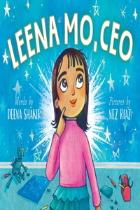](https://www.bookswagon.com/book/leena-mo-ceo-nez-riaz/9781665935654)

**Leena Mo, CEO**Nez Riaz

No Review Yet

**₹920**

**40%**

[](https://www.bookswagon.com/book/untitled-5115-al-pacino/9780593655115)

**Sonny Boy**Al Pacino

No Review Yet

**₹1,848**

**33%**

[](https://www.bookswagon.com/book/hidden-power-five-hearts-kimberly/9781401977269)

**Hidden Power of the Five Hearts**Kimberly Snyder

No Review Yet

**₹1,474**

**24%**

[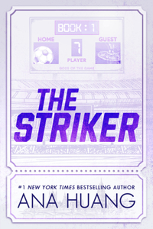](https://www.bookswagon.com/book/striker-ana-huang/9781464223327)

**Striker (Deluxe Edition)**Ana Huang

No Review Yet

**₹1,271**

**23%**

[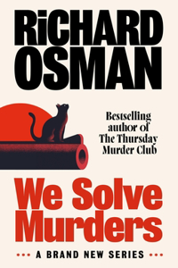](https://www.bookswagon.com/book/untitled-richard-osman/9780241608364)

**We Solve Murders**Richard Osman

No Review Yet

**₹1,838**

**23%**

[](https://www.bookswagon.com/book/creation-lake-rachel-kushner/9781787331747)

**Creation Lake**Rachel Kushner

No Review Yet

**₹1,587**

**27%**

[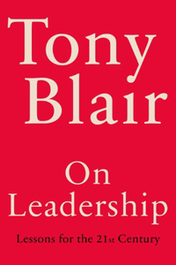](https://www.bookswagon.com/book/leadership-tony-blair/9781529151510)

**On Leadership**Tony Blair

No Review Yet

**₹1,980**

**37%**

[](https://www.bookswagon.com/book/siege-ben-macintyre/9780593728093)

**Siege**Ben Macintyre

No Review Yet

**₹1,754**

**20%**

[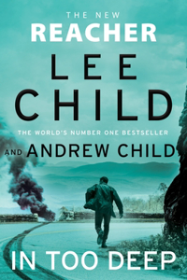](https://www.bookswagon.com/book/in-too-deep-lee-andrew/9780857505606)

**In Too Deep**Lee Child

No Review Yet

**₹1,388**

**40%**

[](https://www.bookswagon.com/book/counting-miracles-nicholas-sparks/9780593449592)

**Counting Miracles**Nicholas Sparks

No Review Yet

**₹1,584**

**35%**

[](https://www.bookswagon.com/book/lonely-planet-sri-lanka-16/9781838691806)

**Lonely Planet Sri Lanka**Bradley Mayhew

No Review Yet

**₹1,234**

**40%**

[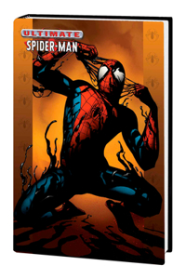](https://www.bookswagon.com/book/ultimate-spiderman-omnibus-vol-4/9781302959555)

**Ultimate Spider-Man Omnibus Vol. 4**David Lafuente

No Review Yet

**₹5,999**

**34%**

[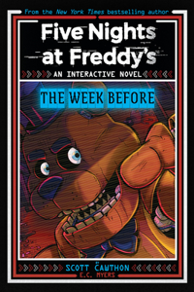](https://www.bookswagon.com/book/five-nights-at-freddys-scott/9781546131113)

**Five Nights at Freddy's: The Week Before, an Afk Book (Interactive Novel #1)**Scott Cawthon

No Review Yet

**₹746**

**40%**

[](https://www.bookswagon.com/book/city-its-uncertain-walls-philip/9780593801970)

**City & Its Uncertain Walls**Philip Gabriel

No Review Yet

**₹2,083**

**42%**

[](https://www.bookswagon.com/book/untitled-memoir-sm--confirmed/9781668067307)

**Dinner for Vampires**To Be Confirmed Simon & Schuster

No Review Yet

**₹1,850**

**25%**

[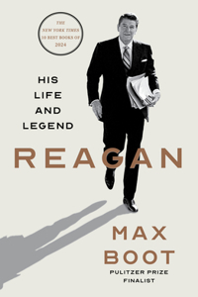](https://www.bookswagon.com/book/reagan-max-boot/9780871409447)

**Reagan**Max Boot

No Review Yet

**₹2,970**

**28%**

[](https://www.bookswagon.com/book/vincent-van-gogh-agathe-braybourret/9780711292024)

**Vincent Van Gogh**Agathe Bray-Bourret

No Review Yet

**₹1,014**

**33%**

[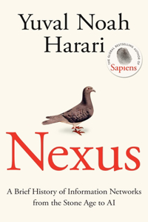](https://www.bookswagon.com/book/untitled-332537-yuval-noah-harari/9781911717089)

**Nexus**Yuval Noah Harari

No Review Yet

**₹1,071**

[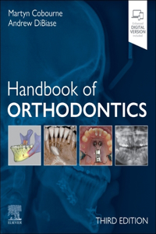](https://www.bookswagon.com/book/handbook-orthodontics-martyn-cobourne-andrew/9780323882613)

**Handbook of Orthodontics**Martyn T Cobourne

No Review Yet

**₹4,396**

**25%**

[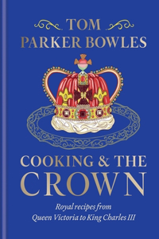](https://www.bookswagon.com/book/cooking-crown-tom-parker-bowles/9781783256068)

**Cooking and the Crown**Tom Parker Bowles

No Review Yet

**₹2,441**

**38%**

[](https://www.bookswagon.com/book/blood-over-bright-haven-m/9780593873359)

**Blood Over Bright Haven**M L Wang

No Review Yet

**₹1,637**

**39%**

[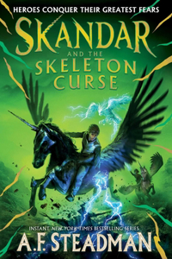](https://www.bookswagon.com/book/untitled-s4--confirmed/9781665966207)

**Skandar and the Skeleton Curse**To Be Confirmed

No Review Yet

**₹1,274**

**43%**

[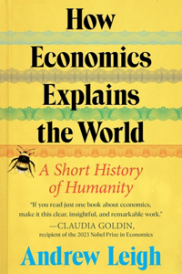](https://www.bookswagon.com/book/economists-history-world-andrew-leigh/9780063383784)

**How Economics Explains the World**Andrew Leigh

No Review Yet

**₹1,304**

**31%**

[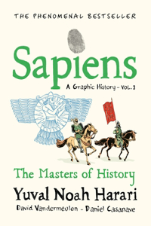](https://www.bookswagon.com/book/sapiens-a-graphic-history-volume/9781911717263)

**Sapiens A Graphic History, Volume 3**David Vandermeulen

No Review Yet

**₹863**

**28%**

[](https://www.bookswagon.com/book/lonely-planet-best-in-travel/9781837582990)

**Lonely Planet Best in Travel 2025**Lonely Planet

No Review Yet

**₹1,253**

**26%**

[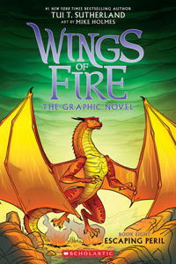](https://www.bookswagon.com/book/escaping-peril-tui-t-sutherland/9781339001234)

**Escaping Peril (Wings of Fire #8)**Tui T Sutherland

No Review Yet

**₹895**

**30%**

[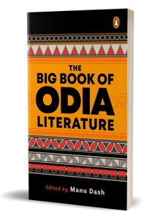](https://www.bookswagon.com/book/big-book-odia-literature-manu/9780143463344)

**Big Book of Odia Literature**Manu Dash

No Review Yet

**₹489**

**25%**

[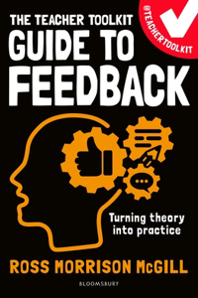](https://www.bookswagon.com/book/teacher-toolkit-guide-feedback-ross/9781801995252)

**The Teacher Toolkit Guide to Feedback**Ross Morrison McGill

No Review Yet

**₹1,058**

**37%**

[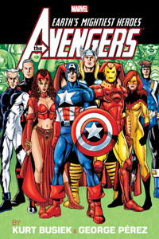](https://www.bookswagon.com/book/avengers-by-busiek-perez-omnibus/9781302959012)

**Avengers by Busiek & Perez Omnibus Vol. 2 George Perez 25th Issue Cover [New Pri Nting]**Kurt Busiek

No Review Yet

**₹6,930**

**21%**

[](https://www.bookswagon.com/book/quicksilver-callie-hart/9781399745413)

**Quicksilver**Callie Hart

No Review Yet

**₹1,714**

**34%**

[](https://www.bookswagon.com/book/sweet-valley-twins-francine-pascal/9780593897089)

**Sweet Valley Twins: Twinning Boxed Set**Francine Pascal

No Review Yet

**₹3,251**

**28%**

[](https://www.bookswagon.com/book/oak-tree-sandoy-julia-donaldson/9780702324352)

**The Oak Tree**Julia Donaldson

No Review Yet

**₹624**

**15%**

[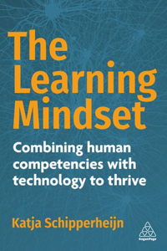](https://www.bookswagon.com/book/learning-mindset-katja-schipperheijn/9781398617339)

**Learning Mindset**Katja Schipperheijn

No Review Yet

**₹3,142**

**29%**

[](https://www.bookswagon.com/book/secret-lives-numbers-timothy-revell/9780241994351)

**The Secret Lives of Numbers**Timothy Revell

No Review Yet

**₹425**

**31%**

[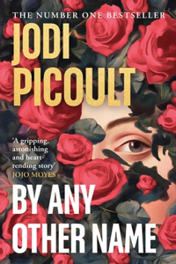](https://www.bookswagon.com/book/by-any-other-name-jodi/9780241676059)

**By Any Other Name**Jodi Picoult

No Review Yet

**₹620**

**37%**

[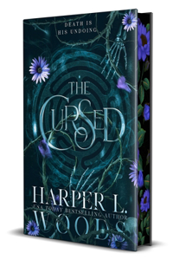](https://www.bookswagon.com/book/cursed-l-harper-l-woods/9781250358943)

**Cursed**Harper L Woods

No Review Yet

**₹1,663**

**31%**

[](https://www.bookswagon.com/book/meditations-mortals-oliver-burkeman/9781847927620)

**Meditations for Mortals**Oliver Burkeman

No Review Yet

**₹551**

**26%**

[](https://www.bookswagon.com/book/vinland-saga-deluxe-4-makoto/9781646519811)

**Vinland Saga Deluxe 4**Makoto Yukimura

No Review Yet

**₹3,582**

**28%**

[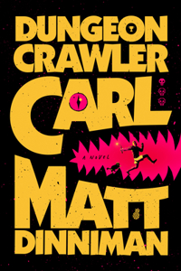](https://www.bookswagon.com/book/dungeon-crawler-carl-matt-dinniman/9780593820247)

**Dungeon Crawler Carl**Matt Dinniman

No Review Yet

**₹1,295**

**39%**

[](https://www.bookswagon.com/book/kingmaker-sonia-purnell/9780593297803)

**Kingmaker**Sonia Purnell

No Review Yet

**₹1,879**

**36%**

[](https://www.bookswagon.com/book/song-drown-rivers-ann-liang/9781250289469)

**A Song to Drown Rivers**Ann Liang

No Review Yet

**₹1,802**

**42%**

[](https://www.bookswagon.com/book/unti9780063359260-anon9780063359260/9780063359260)

**Open When**Julie Smith

No Review Yet

**₹1,463**

**43%**

[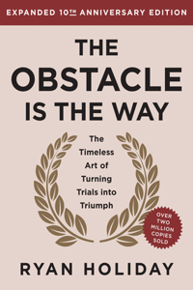](https://www.bookswagon.com/book/obstacle-way-10th-anniversary-edition/9780593719916)

**Obstacle Is The Way 10Th Anniv**Ryan Holiday

No Review Yet

**₹1,404**

**38%**

[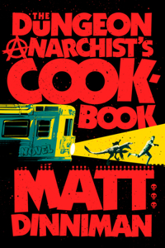](https://www.bookswagon.com/book/dungeon-anarchists-cookbook-matt-dinniman/9780593820285)

**The Dungeon Anarchist's Cookbook**Matt Dinniman

No Review Yet

**₹1,637**

**23%**

[](https://www.bookswagon.com/book/follow-your-tao-stephanie-nosco/9781801293174)

**Follow Your Tao**Stephanie Nosco

No Review Yet

**₹1,439**

**32%**

[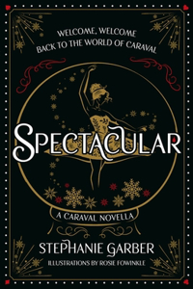](https://www.bookswagon.com/book/spectacular-stephanie-garber/9781399721516)

**Spectacular**Stephanie Garber

No Review Yet

**₹1,106**

**38%**

[](https://www.bookswagon.com/book/sofra-sivine-tabbouch-karima-hazim/9781837831159)

**Sofra**Karima Hazim

No Review Yet

**₹2,077**

**28%**

[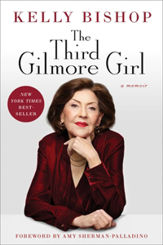](https://www.bookswagon.com/book/third-gilmore-girl-kelly-bishop/9781668023778)

**Third Gilmore Girl**Amy Sherman-Palladino

No Review Yet

**₹1,837**

**38%**

[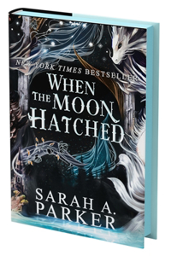](https://www.bookswagon.com/book/moon-hatched-sarah-a-parker/9780063415843)

**When the Moon Hatched**Sarah A Parker

No Review Yet

**₹1,746**

**44%**

[](https://www.bookswagon.com/book/fgteev-graphic-novel-5-fgteev/9780063260535)

**FGTeeV: Blasts Off!**Fgteev

No Review Yet

**₹1,169**

**26%**

[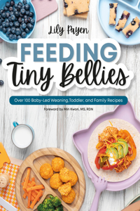](https://www.bookswagon.com/book/feeding-tiny-bellies-min-kwon/9780744097948)

**Feeding Tiny Bellies**Min Kwon

No Review Yet

**₹1,183**

**31%**

[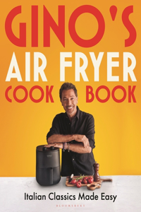](https://www.bookswagon.com/book/ginos-air-fryer-cookbook-dacampo/9781526680419)

**Gino's Air Fryer Cookbook**Gino D'Acampo

No Review Yet

**₹620**

**31%**

[](https://www.bookswagon.com/book/eighteen-alice-loxton/9781035031283)

**Eighteen**Alice Loxton

No Review Yet

**₹1,801**

**30%**

[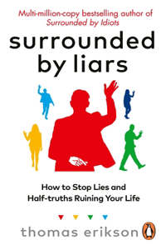](https://www.bookswagon.com/book/surrounded-by-liars-thomas-erikson/9781785044762)

**Surrounded by Liars**Thomas Erikson

No Review Yet

**₹489**

**29%**

[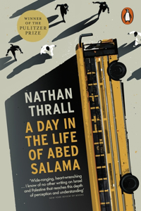](https://www.bookswagon.com/book/day-in-life-abed-salama/9781802060041)

**A Day in the Life of Abed Salama**Nathan Thrall

No Review Yet

**₹425**

**17%**

[](https://www.bookswagon.com/book/tales-from-pizzaplex-box-set/9781546128359)

**Five Nights at Freddy's: Tales from the Pizza Plex Box Set**Kelly Parra

No Review Yet

**₹6,422**

**26%**

[](https://www.bookswagon.com/book/ottolenghi-comfort-alternate-cover-edition/9780593836941)

**Ottolenghi Comfort [Alternate Cover Edition]**Yotam Ottolenghi

No Review Yet

**₹2,475**

**40%**

[](https://www.bookswagon.com/book/how-build-a-fashion-icon/9781419768217)

**How to Build a Fashion Icon**Law Roach

No Review Yet

**₹1,462**

**23%**

[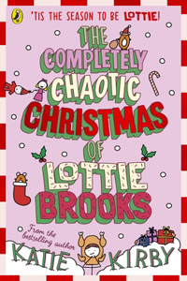](https://www.bookswagon.com/book/completely-chaotic-christmas-lottie-brooks/9780241679166)

**The Completely Chaotic Christmas of Lottie Brooks**Katie Kirby

No Review Yet

**₹677**

**49%**

[](https://www.bookswagon.com/book/granny-square-card-deck-claire/9781800922297)

**The Granny Square Card Deck**Claire Montgomerie

No Review Yet

**₹896**

**35%**

[](https://www.bookswagon.com/book/want-gillian-anderson/9781526657947)

**Want**Gillian Anderson

No Review Yet

**₹454**

**29%**

[](https://www.bookswagon.com/book/money-trap-alok-sama/9781035049325)

**The Money Trap**Alok Sama

No Review Yet

**₹1,695**

**27%**

[](https://www.bookswagon.com/book/real-healthy-melissa-hemsley/9781529940251)

**Real Healthy**MELISSA HEMSLEY

No Review Yet

**₹1,313**

**35%**

[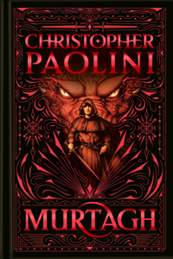](https://www.bookswagon.com/book/untitled-knopf-bfyr-8000/9780593898000)

**Murtagh: Deluxe Edition**Christopher Paolini

No Review Yet

**₹2,059**

**35%**

[](https://www.bookswagon.com/book/minecraft-advent-calendar-mojang-ab/9780008620110)

**Minecraft Advent Calendar: Book Collection**Mojang Ab

No Review Yet

**₹1,659**

**26%**

[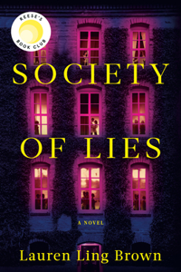](https://www.bookswagon.com/book/society-lies-lauren-ling-brown/9780593723357)

**Society of Lies: Reese's Book Club**Lauren Ling Brown

No Review Yet

**₹1,954**

**39%**

[](https://www.bookswagon.com/book/how-retire-christine-benz/9781804090695)

**How to Retire**Christine Benz

No Review Yet

**₹365**

**29%**

[](https://www.bookswagon.com/book/cooking-my-way-my-nguyen/9780593580189)

**Healthy, My Way**My Nguyen

No Review Yet

**₹2,080**

**32%**

[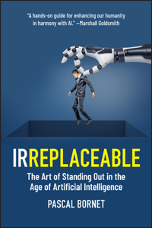](https://www.bookswagon.com/book/irreplaceable-pascal-bornet/9781394264407)

**IRREPLACEABLE**Pascal Bornet

No Review Yet

**₹1,656**

**35%**

[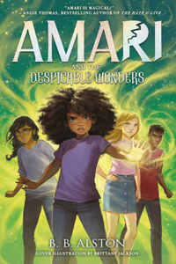](https://www.bookswagon.com/book/amari-despicable-wonders-bb-alston/9780008645168)

**Amari and the Despicable Wonders**BB Alston

No Review Yet

**₹389**

**37%**

[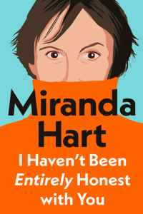](https://www.bookswagon.com/book/untitled-mj-333068-author-mj/9781405958332)

**I Haven’t Been Entirely Honest with You**Miranda Hart

No Review Yet

**₹2,028**

**35%**

[](https://www.bookswagon.com/book/turtle-moon-levi-pinfold-hannah/9780008582050)

**Turtle Moon**Levi Pinfold

No Review Yet

**₹1,072**

**17%**

[](https://www.bookswagon.com/book/development-art-history-in-uae/9781839992407)

**Development of an Art History in the Uae**Sophie Kazan Makhlouf

No Review Yet

**₹2,527**

**29%**

[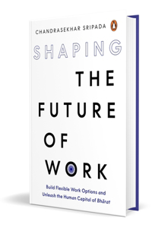](https://www.bookswagon.com/book/shaping-future-work-chandrasekhar-sripada/9780143469032)

**Shaping the Future of Work**Chandrasekhar Sripada

No Review Yet

**₹425**

**24%**

[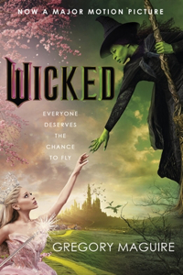](https://www.bookswagon.com/book/wicked-gregory-maguire/9781035421060)

**Wicked**Gregory Maguire

No Review Yet

**₹919**

**31%**

[](https://www.bookswagon.com/book/life-impossible-matt-haig/9781838855574)

**The Life Impossible**Matt Haig

No Review Yet

**₹689**

**43%**

[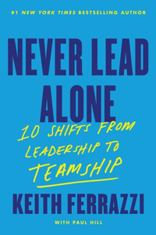](https://www.bookswagon.com/book/never-lead-alone-keith-ferrazzi/9780063412576)

**Never Lead Alone**Keith Ferrazzi

No Review Yet

**₹1,605**

**35%**

[](https://www.bookswagon.com/book/history-middleearth-boxed-set-4/9780008669393)

**The History of Middle-earth (Boxed Set 4)**Christopher Tolkien

No Review Yet

**₹5,849**

**25%**

[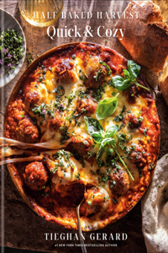](https://www.bookswagon.com/book/untitled-2576/9780593232576)

**Half Baked Harvest Quick & Cozy**Tieghan Gerard

No Review Yet

**₹1,088**

**37%**

[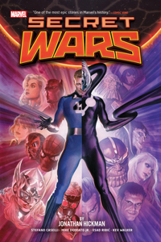](https://www.bookswagon.com/book/secret-wars-by-jonathan-hickman/9781302959777)

**Secret Wars by Jonathan Hickman Omnibus**Alex Ross

No Review Yet

**₹5,544**

**32%**

[](https://www.bookswagon.com/book/vibes-good-life-calendar-2025/9781837822454)

**Good Vibes, Good Life Calendar 2025**Vex King

No Review Yet

**₹986**

**38%**

[](https://www.bookswagon.com/book/pixar-s-t-bende-tara/9781647229702)

**Pixar: The Official Cookbook**S. T. Bende

No Review Yet

**₹2,158**

**28%**

[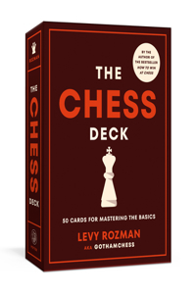](https://www.bookswagon.com/book/chess-deck-levy-rozman/9780593580141)

**The Chess Deck**Levy Rozman

No Review Yet

**₹1,394**

**42%**

[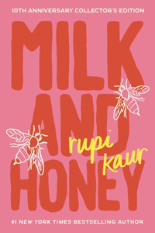](https://www.bookswagon.com/book/milk-honey-rupi-kaur/9781524892876)

**Milk and Honey**Rupi Kaur

No Review Yet

**₹927**

**37%**

[](https://www.bookswagon.com/book/avatar-last-airbender-randy-ribay/9781419776038)

**Avatar, the Last Airbender: The Reckoning of Roku (Chronicles of the Avatar Book 5)**Randy Ribay

No Review Yet

**₹1,206**

**18%**

[](https://www.bookswagon.com/book/ancient-chants-modern-living-ram/9780143459736)

**Ancient Chants for Modern Living**Aatmanika Ram

No Review Yet

**₹205**

**32%**

[](https://www.bookswagon.com/book/exceptional-watches-clement-cl%C3%A9ment-mazarian/9781784729448)

**Exceptional Watches**Clement Mazarian

No Review Yet

**₹2,754**

**15%**

[](https://www.bookswagon.com/book/future-luxury-customer-experience-gabriella/9781398615458)

**Future of Luxury Customer Experience**Gabriella Lojacono

No Review Yet

**₹3,890**

**52%**

[](https://www.bookswagon.com/book/motherkind-zoe-blaskey/9780008650827)

**Motherkind**Zoe Blaskey

No Review Yet

**₹1,267**

**39%**

[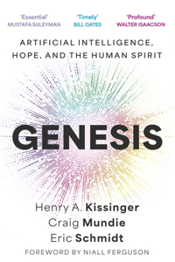](https://www.bookswagon.com/book/genesis-craig-mundie-eric-iii/9781399819107)

**Genesis**Craig Mundie

No Review Yet

**₹1,476**

**44%**

[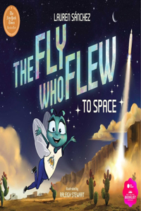](https://www.bookswagon.com/book/fly-who-flew-space-raleigh/9781685550639)

**The Fly Who Flew to Space (with removable glow-in-the-dark poster)**Raleigh Stewart

No Review Yet

**₹972**

**31%**

[](https://www.bookswagon.com/book/irish-country-house-robert-obyrne/9780847832835)

**Irish Country House**Robert O'Byrne

No Review Yet

**₹3,947**

**34%**

[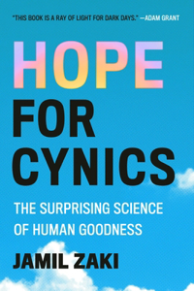](https://www.bookswagon.com/book/hope-cynics-jamil-zaki/9781538743065)

**Hope for Cynics**Jamil Zaki

No Review Yet

**₹1,742**

**39%**

[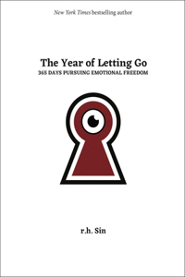](https://www.bookswagon.com/book/year-letting-go-r-h/9781524889234)

**Year of Letting Go**R H Sin

No Review Yet

**₹1,342**

**40%**

[](https://www.bookswagon.com/book/karlas-choice-nick-harkaway/9780593833490)

**Karla's Choice**Nick Harkaway

No Review Yet

**₹1,584**

**29%**

[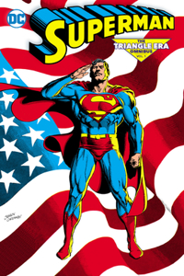](https://www.bookswagon.com/book/superman-jackson-guice-roger-stern/9781779528162)

**Superman: The Triangle Era Omnibus Vol. 1**Jackson Guice

No Review Yet

**₹7,099**

**27%**

[](https://www.bookswagon.com/book/rc-untitled-rc/9781529945928)

**Hardest Geezer**Rc

No Review Yet

**₹1,743**

**26%**

[](https://www.bookswagon.com/book/adventures-in-time-dominic-sandbrook/9780241552216)

**Adventures in Time: Nelson, Hero of the Seas**Dominic Sandbrook

No Review Yet

**₹739**

**33%**

[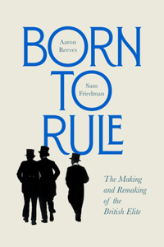](https://www.bookswagon.com/book/born-rule-sam-friedman-aaron/9780674257719)

**Born to Rule**Sam Friedman

No Review Yet

**₹1,766**

**32%**

[](https://www.bookswagon.com/book/targeted-james-m-scott-jack/9781668024355)

**Targeted: Beirut**James Scott

No Review Yet

**₹1,855**

**38%**

[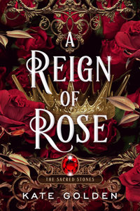](https://www.bookswagon.com/book/reign-rose-kate-golden/9780593641941)

**Reign of Rose**Kate Golden

No Review Yet

**₹1,037**

**31%**

[](https://www.bookswagon.com/book/plant-protein-gigi-grassia/9781529440409)

**Plant Protein**Gigi Grassia

No Review Yet

**₹1,822**

**24%**

[](https://www.bookswagon.com/book/i-love-you-pamela-anderson/9781408731703)

**I Love You: Recipes from the heart**Pamela Anderson

No Review Yet

**₹2,144**

**30%**

[](https://www.bookswagon.com/book/blue-lock-15-yusuke-nomura/9781646516728)

**Blue Lock 15**Yusuke Nomura

No Review Yet

**₹801**

**31%**

[](https://www.bookswagon.com/book/freedom-timothy-snyder/9781847928061)

**On Freedom**Timothy Snyder

No Review Yet

**₹620**

**29%**

[](https://www.bookswagon.com/book/not-end-world-hannah-ritchie/9781529931242)

**Not the End of the World**Hannah Ritchie

No Review Yet

**₹425**

**32%**

[](https://www.bookswagon.com/book/lady-pamela-india-hicks/9780847828623)

**Lady Pamela**India Hicks

No Review Yet

**₹3,590**

**29%**

[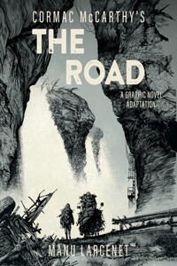](https://www.bookswagon.com/book/road-cormac-mccarthy-manu-larcenet/9781419776779)

**The Road**Cormac McCarthy

No Review Yet

**₹1,463**

**23%**

[](https://www.bookswagon.com/book/mercedesbenz-milestones-k%C3%B6ckritz-michael-kockritz/9783961715596)

**Mercedes-Benz Milestones**Michael Köckritz

No Review Yet

**₹3,760**

**31%**

[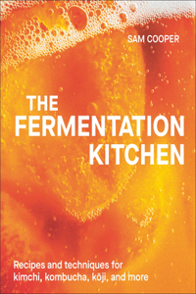](https://www.bookswagon.com/book/fermenters-companion-sam-cooper/9780593847893)

**Fermentation Kitchen**Sam Cooper

No Review Yet

**₹1,518**

**51%**

[](https://www.bookswagon.com/book/strangeland-jon-sopel/9781529938401)

**Strangeland**Jon Sopel

No Review Yet

**₹1,833**

**27%**

[](https://www.bookswagon.com/book/i-ate-in-one-year/9780241683132)

**What I Ate in One Year**Stanley Tucci

No Review Yet

**₹1,606**

**25%**

[](https://www.bookswagon.com/book/thriving-beyond-fifty-expanded-edition/9781401994181)

**Thriving Beyond Fifty (Expanded Edition)**Will Harlow

No Review Yet

**₹1,518**

**30%**

[](https://www.bookswagon.com/book/fficial-dopamine-nation-workbook-dr/9781035416554)

**The Official Dopamine Nation Workbook**Dr Anna Lembke

No Review Yet

**₹1,139**

**37%**

[](https://www.bookswagon.com/book/home-edit-teens-clea-shearer/9780593712221)

**The Home Edit for Teens**Clea Shearer

No Review Yet

**₹440**

**39%**

[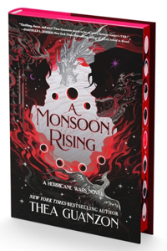](https://www.bookswagon.com/book/hurricane-wars-2-thea-guanzon/9780063277304)

**Monsoon Rising**Thea Guanzon

No Review Yet

**₹1,718**

**35%**

[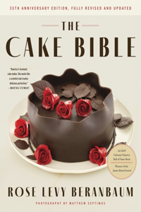](https://www.bookswagon.com/book/cake-bible-35th-anniversary-edition/9780063310278)

**The Cake Bible, 35th Anniversary Edition**Rose Levy Beranbaum

No Review Yet

**₹1,299**

**13%**

[](https://www.bookswagon.com/book/advent-calendar-book-collection-usborne/9781835404447)

**Advent Calendar Book Collection**Usborne

No Review Yet

**₹1,892**

**36%**

[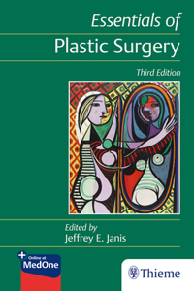](https://www.bookswagon.com/book/essentials-plastic-surgery-jeffrey-janis/9781626238473)

**Essentials of Plastic Surgery**Jeffrey Janis

No Review Yet

**₹8,832**

**22%**

[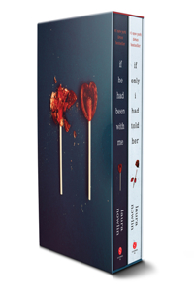](https://www.bookswagon.com/book/he-been-me-if-only/9781464239953)

**If He Had Been with Me and If Only I Had Told Her Box Set**Laura Nowlin

No Review Yet

**₹1,544**

**28%**

[](https://www.bookswagon.com/book/morbidly-yours-ivy-fairbanks/9781804995341)

**Morbidly Yours**Ivy Fairbanks

No Review Yet

**₹396**

[](https://www.bookswagon.com/book/future-stories-in-global-heritage/9781032804385)

**Future Stories in the Global Heritage Industry**Alia Yunis

No Review Yet

**₹15,826**

**8%**

[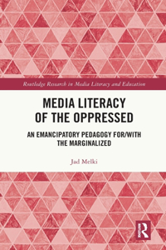](https://www.bookswagon.com/book/media-literacy-oppressed-jad-melki/9780367334888)

**Media Literacy of the Oppressed**Jad Melki

No Review Yet

**₹14,407**

**25%**

[](https://www.bookswagon.com/book/iris-apfel-iris-apfel/9781419776601)

**Iris Apfel: Colorful**Iris Apfel

No Review Yet

**₹3,263**

**28%**

[](https://www.bookswagon.com/book/forever-beautiful-amy-neunsinger-mark/9780847830114)

**Forever Beautiful**Amy Neunsinger

No Review Yet

**₹2,851**

**24%**

[](https://www.bookswagon.com/book/good-material-dolly-alderton/9780241993163)

**Good Material**DOLLY ALDERTON

No Review Yet

**₹835**

**26%**

[](https://www.bookswagon.com/book/night-before-christmasaurus-tom-fletcher/9780241591109)

**The Christmasaurus and the Night Before Christmas**Tom Fletcher

No Review Yet

**₹1,043**

**38%**

[](https://www.bookswagon.com/book/house-dragon-jim-mcdermott/9780762487264)

**House of the Dragon: Balerion Light-Up Dragon Skull**Jim McDermott

No Review Yet

**₹874**

**27%**

[](https://www.bookswagon.com/book/frequently-happy-david-larbi/9781846048326)

**Frequently Happy**David Larbi

No Review Yet

**₹1,364**

**2%**

[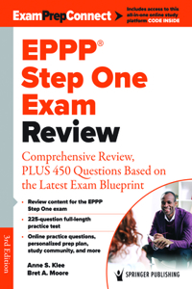](https://www.bookswagon.com/book/eppp-step-one-exam-review/9780826190215)

**Eppp Step One Exam Review**Bret A Moore

No Review Yet

**₹11,211**

**8%**

[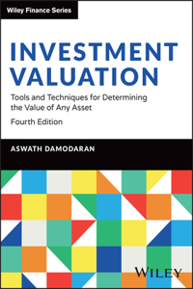](https://www.bookswagon.com/book/investment-valuation-aswath-damodaran/9781394254606)

**Investment Valuation**Aswath Damodaran

No Review Yet

**₹10,485**

**27%**

[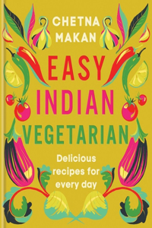](https://www.bookswagon.com/book/easy-indian-vegetarian-chetna-makan/9780600637752)

**Easy Indian Vegetarian**Chetna Makan

No Review Yet

**₹2,088**

**41%**

[](https://www.bookswagon.com/book/chainsaw-man-vol-16-tatsuki/9781974748747)

**Chainsaw Man, Vol. 16**Tatsuki Fujimoto

No Review Yet

**₹623**

**28%**

[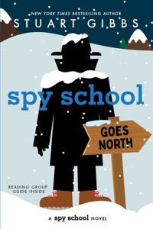](https://www.bookswagon.com/book/spy-school-goes-north-stuart/9781665934756)

**Spy School Goes North**Stuart Gibbs

No Review Yet

**₹570**

**36%**

[](https://www.bookswagon.com/book/untitled-rt-rosemarie-terenzio-confirmed/9781668018514)

**JFK Jr.**RoseMarie Terenzio

No Review Yet

**₹1,726**

**20%**

[](https://www.bookswagon.com/book/think-again-jacqueline-wilson/9780857506115)

**Think Again**Jacqueline Wilson

No Review Yet

**₹1,388**

**33%**

[](https://www.bookswagon.com/book/opus-gareth-gore/9781668016145)

**Opus**Gareth Gore

No Review Yet

**₹1,828**

**26%**

[](https://www.bookswagon.com/book/greatest-nobodies-history-adrian-bliss/9781529907469)

**The Greatest Nobodies of History**Adrian Bliss

No Review Yet

**₹665**

**34%**

[](https://www.bookswagon.com/book/genesis-craig-mundie-eric-schmidt/9780316581295)

**Genesis**Craig Mundie

No Review Yet

**₹1,742**

**30%**

[](https://www.bookswagon.com/book/forthcoming-book-by-matt-whyman/9780593735640)

**Inside Mercedes F1**Matt Whyman

No Review Yet

**₹1,848**

**8%**

[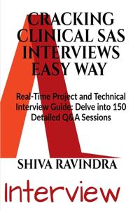](https://www.bookswagon.com/book/cracking-clinical-sas-interviews-easy/9798894150581)

**Cracking Clinical SAS Interviews Easy Way**Shiva Ravindra

No Review Yet

**₹2,195**

**35%**

[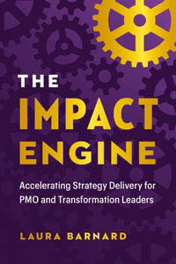](https://www.bookswagon.com/book/impact-engine-laura-barnard/9781774584521)

**Impact Engine**Laura Barnard

No Review Yet

**₹1,713**

**31%**

[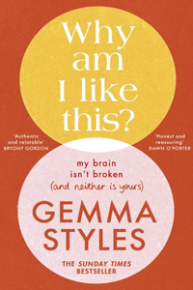](https://www.bookswagon.com/book/why-am-i-like-this/9780857505095)

**Why Am I Like This?**Gemma Styles

No Review Yet

**₹689**

**35%**

[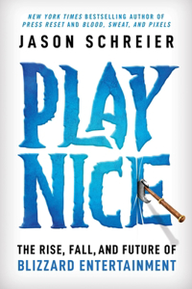](https://www.bookswagon.com/book/play-nice-jason-schreier/9781538725429)

**Play Nice**Jason Schreier

No Review Yet

**₹1,763**

**35%**

[](https://www.bookswagon.com/book/clown-world-matt-shea-investigative/9781529437829)

**Clown World**Matt Shea

No Review Yet

**₹1,602**

**42%**

[](https://www.bookswagon.com/book/artful-way-plantbased-cooking-trudy/9781668026946)

**The Artful Way to Plant-Based Cooking**Trudy Crane

No Review Yet

**₹1,786**

**42%**

[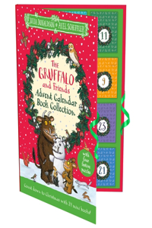](https://www.bookswagon.com/book/gruffalo-friends-advent-calendar-book/9781035032990)

**The Gruffalo and Friends Advent Calendar Book Collection**Julia Donaldson

No Review Yet

**₹1,159**

**26%**

[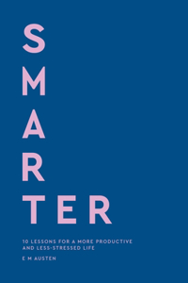](https://www.bookswagon.com/book/smarter-emily-austen/9780349443737)

**Smarter**Emily Austen

No Review Yet

**₹1,525**

**40%**

[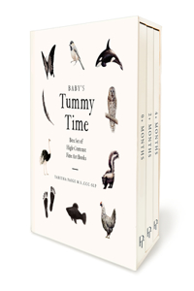](https://www.bookswagon.com/book/babys-tummy-time-book-box/9781958803899)

**Baby's Tummy Time Book Box Set**Tabitha Paige

No Review Yet

**₹2,279**

**30%**

[](https://www.bookswagon.com/book/stone-island-angelo-flaccavento-carlo/9780847838653)

**Stone Island: Revised & Update**Angelo Flaccavento

No Review Yet

**₹4,620**

**41%**

[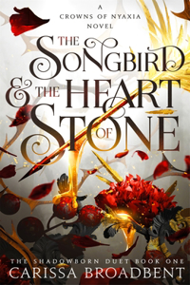](https://www.bookswagon.com/book/songbird-heart-stone-carissa-broadbent/9781035050727)

**The Songbird and the Heart of Stone**Carissa Broadbent

No Review Yet

**₹443**

**42%**

[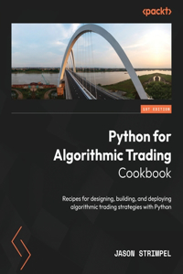](https://www.bookswagon.com/book/python-algorithmic-trading-cookbook-jason/9781835084700)

**Python for Algorithmic Trading Cookbook**Jason Strimpel

No Review Yet

**₹4,824**

**29%**

[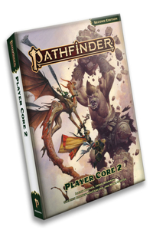](https://www.bookswagon.com/book/pathfinder-rpg-logan-bonner-mark/9781640785977)

**Pathfinder Rpg: Player Core 2 (P2)**Logan Bonner

No Review Yet

**₹3,407**

**44%**

[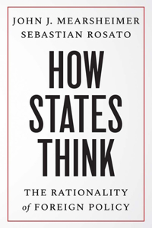](https://www.bookswagon.com/book/how-states-think-j-john/9780300279870)

**How States Think**John J Mearsheimer

No Review Yet

**₹986**

**34%**

[](https://www.bookswagon.com/book/bismillah-lets-eat-zehra-allibhai/9780306831119)

**Bismillah, Let's Eat!**Zehra Allibhai

No Review Yet

**₹2,148**

**44%**

[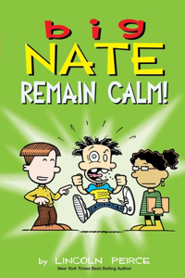](https://www.bookswagon.com/book/big-nate-lincoln-peirce/9781524890438)

**Big Nate: Remain Calm!**Lincoln Peirce

No Review Yet

**₹641**

**34%**

[](https://www.bookswagon.com/book/official-agatha-christie-puzzle-book/9781399627931)

**The Official Agatha Christie Puzzle Book**Agatha Christie Ltd

No Review Yet

**₹461**

**34%**

[](https://www.bookswagon.com/book/kagurabachi-vol-1-takeru-hokazono/9781974747245)

**Kagurabachi, Vol. 1**Takeru Hokazono

No Review Yet

**₹697**

**22%**

[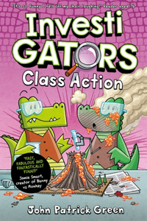](https://www.bookswagon.com/book/investigators-john-patrick-green/9781035015436)

**InvestiGators Class Action**John Patrick Green

No Review Yet

**₹1,100**

**37%**

[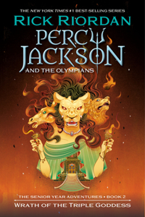](https://www.bookswagon.com/book/percy-jackson-olympians-rick-riordan/9781368107631)

**Percy Jackson and the Olympians: Wrath of the Triple Goddess**Rick Riordan

No Review Yet

**₹1,096**

**34%**

[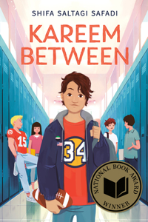](https://www.bookswagon.com/book/kareem-between-shifa-saltagi-safadi/9780593699263)

**Kareem Between**Shifa Saltagi Safadi

No Review Yet

**₹1,217**

**33%**

[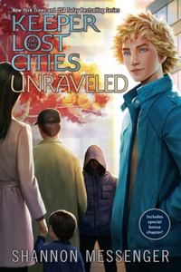](https://www.bookswagon.com/book/unraveled-book-95-shannon-messenger/9781665967419)

**Unraveled Book 9.5**Shannon Messenger

No Review Yet

**₹1,282**

**5%**

[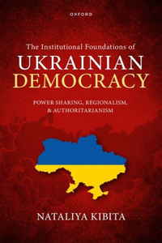](https://www.bookswagon.com/book/institutional-foundations-ukrainian-democracy-nataliya/9780192898814)

**Institutional Foundations of Ukrainian Democracy**Nataliya Kibita

No Review Yet

**₹12,436**

**3%**

[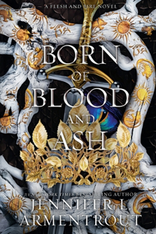](https://www.bookswagon.com/book/born-blood-ash-jennifer-l/9781963135343)

**Born of Blood and Ash**Jennifer L Armentrout

No Review Yet

**₹2,210**

**5%**

[](https://www.bookswagon.com/book/japanese-capitalism-entrepreneurship-donz%C3%A9-pierreyves/9780192887474)

**Japanese Capitalism and Entrepreneurship**Pierre-yves Donzé

No Review Yet

**₹9,405**

**26%**

[](https://www.bookswagon.com/book/fear-flames-olivia-rose-darling/9780593873892)

**Fear the Flames**Olivia Rose Darling

No Review Yet

**₹1,888**

**39%**

[](https://www.bookswagon.com/book/how-live-extraordinary-life-anthony/9780857199928)

**How to Live an Extraordinary Life**Anthony Pompliano

No Review Yet

**₹1,557**

**21%**

[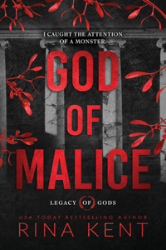](https://www.bookswagon.com/book/god-malice-standard-edition-rina/9781464238864)

**God of Malice (Standard Edition)**Rina Kent

No Review Yet

**₹1,321**

**39%**

[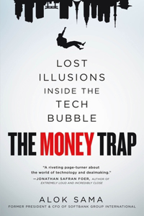](https://www.bookswagon.com/book/money-trap-alok-sama/9781250332844)

**Money Trap**Alok Sama

No Review Yet

**₹1,610**

**34%**

[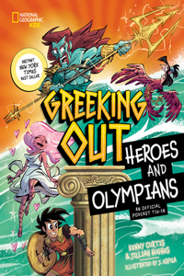](https://www.bookswagon.com/book/greeking-out-heroes-olympians-jillian/9781426376276)

**Greeking Out Heroes and Olympians**Jillian Hughes

No Review Yet

**₹1,162**

**26%**

[](https://www.bookswagon.com/book/good-lookin-cookin-dolly-rachel/9781984863164)

**Good Lookin' Cookin'**Dolly Parton

No Review Yet

**₹2,279**

**27%**

[](https://www.bookswagon.com/book/under-oak-tree-vol-1/9781911720232)

**Under the Oak Tree, Vol. 1 (novel)**Suji Kim

No Review Yet

**₹1,240**

**38%**

[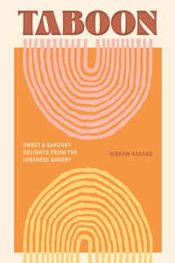](https://www.bookswagon.com/book/taboon-hisham-assaad/9781923049437)

**Taboon**Hisham Assaad

No Review Yet

**₹2,155**

**36%**

[](https://www.bookswagon.com/book/jane-austen-gift-set-jane/9780593623688)

**The Jane Austen Gift Set: A Puffin in Bloom 3-Book Collection**Jane Austen

No Review Yet

**₹2,872**

**24%**

[](https://www.bookswagon.com/book/abdullah-al-saadi-abdullah-al/9786148035678)

**Abdullah Al Saadi: Sometimes You Have to Go a Long Way to Come Back a Short Distance**Abdullah Al Saadi

No Review Yet

**₹2,675**

**33%**

[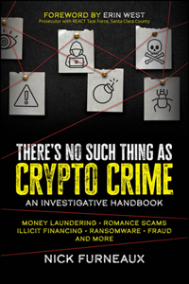](https://www.bookswagon.com/book/theres-no-such-thing-as/9781394164820)

**There's No Such Thing as Crypto Crime**Furneaux

No Review Yet

**₹2,040**

**27%**

[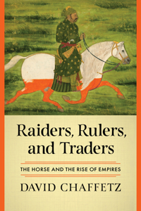](https://www.bookswagon.com/book/raiders-rulers-traders-david-chaffetz/9781324051466)

**Raiders, Rulers, and Traders**David Chaffetz

No Review Yet

**₹2,088**

**35%**

[](https://www.bookswagon.com/book/thousand-feasts-nigel-slater/9780008670740)

**A Thousand Feasts**Nigel Slater

No Review Yet

**₹1,487**

**19%**

[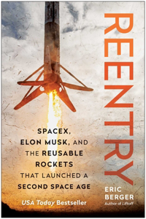](https://www.bookswagon.com/book/reentry-eric-berger/9781637745274)

**Reentry**Eric Berger

No Review Yet

**₹2,278**

**32%**

[](https://www.bookswagon.com/book/you-can-heal-your-life/9781401976910)

**You Can Heal Your Life**Louise Hay

No Review Yet

**₹1,087**

**42%**

[](https://www.bookswagon.com/book/whos-afraid-roman%C3%A9econti-dan-keeling/9781787139886)

**Who's Afraid of Romanee-Conti?**Dan Keeling

No Review Yet

**₹2,297**

**30%**

[](https://www.bookswagon.com/book/ashe-leandro-seth-meyers-rashid/9780847837199)

**Ashe Leandro**Seth Meyers

No Review Yet

**₹4,004**

**31%**

[](https://www.bookswagon.com/book/at-home-in-france-timothy/9780847829262)

**At Home in France**Timothy Corrigan

No Review Yet

**₹3,947**

**34%**

[](https://www.bookswagon.com/book/untitled-ss-nf-wn-/9781668017234)

**Something Lost, Something Gained**Hillary Rodham Clinton

No Review Yet

**₹1,742**

**29%**

[](https://www.bookswagon.com/book/artful-home-josh-young-kirsten/9780847830398)

**Artful Home**Josh Young

No Review Yet

**₹3,436**

**31%**

[](https://www.bookswagon.com/book/carnivore-in-kitchen-courtney-luna/9781628605051)

**Carnivore in the Kitchen**Courtney Luna

No Review Yet

**₹2,183**

**34%**

[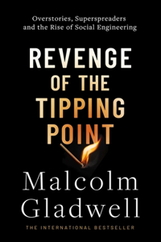](https://www.bookswagon.com/book/revenge-tipping-point-malcolm-gladwell/9780349147185)

**Revenge of the Tipping Point**Malcolm Gladwell

No Review Yet

**₹527**

**21%**

[](https://www.bookswagon.com/book/owlympic-games-rebecca-elliott/9781338880304)

**Owlympic Games: A Branches Book (Owl Diaries #20)**Rebecca Elliott

No Review Yet

**₹487**

**36%**

[](https://www.bookswagon.com/book/blacksad-juan-d%C3%ADaz-canales-juanjo/9781506743981)

**Blacksad: They All Fall Down - Part Two**Juan Díaz Canales

No Review Yet

**₹1,114**

**30%**

[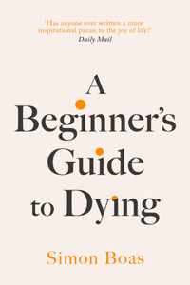](https://www.bookswagon.com/book/eginners-guide-dying-simon-boas/9781800755031)

**A Beginner's Guide to Dying**Simon Boas

No Review Yet

**₹1,139**

**24%**

[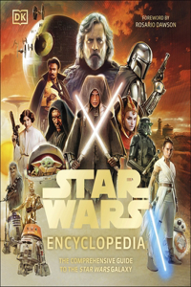](https://www.bookswagon.com/book/star-wars-encyclopedia-zehr-ryder/9780241661628)

**Star Wars Encyclopedia**Dan Zehr

No Review Yet

**₹1,823**

**26%**

[](https://www.bookswagon.com/book/vinland-saga-deluxe-5-makoto/9781646519828)

**Vinland Saga Deluxe 5**Makoto Yukimura

No Review Yet

**₹3,582**

**19%**

[](https://www.bookswagon.com/book/radiohead-tom-sheehan/9781802798012)

**Radiohead: Climbing Up the Walls**Tom Sheehan

No Review Yet

**₹2,819**

**16%**

[](https://www.bookswagon.com/book/minecraft-annual-2025/9780008615673)

**Minecraft Annual 2025**Mojang Ab

No Review Yet

**₹1,109**

**46%**

[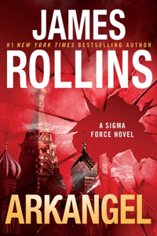](https://www.bookswagon.com/book/arkangel-james-rollins/9780062893161)

**Arkangel**James Rollins

No Review Yet

**₹1,521**

**24%**

[](https://www.bookswagon.com/book/diddly-squat-jeremy-clarkson/9780241728192)

**Diddly Squat: Home to Roost**Jeremy Clarkson

No Review Yet

**₹1,839**

[](https://www.bookswagon.com/book/dungeons-dragons-worlds-realms-adam/9780593835500)

**Dungeons & Dragons Worlds & Realms**Adam Lee

No Review Yet

**₹2,841**

**22%**

[](https://www.bookswagon.com/book/wisteria-adalyn-grace/9781399726092)

**Wisteria**Adalyn Grace

No Review Yet

**₹1,269**

**30%**

[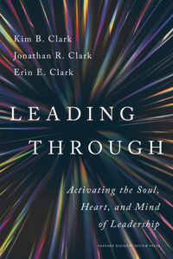](https://www.bookswagon.com/book/leading-through-b-kim-b/9781647827618)

**Leading Through**Kim B. Clark

No Review Yet

**₹2,132**

**2%**

[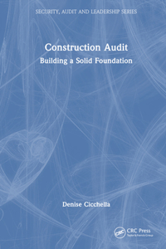](https://www.bookswagon.com/book/construction-audit-denise-cicchella/9781032610030)

**Construction Audit**Denise Cicchella

No Review Yet

**₹12,760**

**29%**

[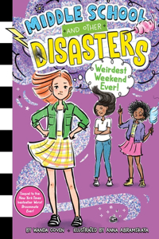](https://www.bookswagon.com/book/weirdest-weekend-ever-anna-abramskaya/9781665949248)

**Weirdest Weekend Ever!**Anna Abramskaya

No Review Yet

**₹937**

**32%**

[](https://www.bookswagon.com/book/absolutely-chanel-catherine-ormen/9781529438239)

**Absolutely Chanel**Catherine Ormen

No Review Yet

**₹2,754**

**36%**

[](https://www.bookswagon.com/book/lonely-planet-australia-22-lonely/9781838693909)

**Lonely Planet Australia**Sarah Reid

No Review Yet

**₹1,670**

**19%**

[](https://www.bookswagon.com/book/english-vision-ben-pentreath/9780847866670)

**English Vision, An**Ben Pentreath

No Review Yet

**₹4,277**

**43%**

[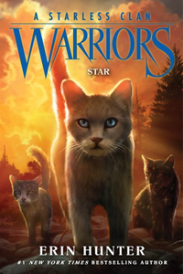](https://www.bookswagon.com/book/warriors-erin-hunter/9780063050396)

**Warriors: A Starless Clan #6: Star**Erin Hunter

No Review Yet

**₹1,003**

**37%**

[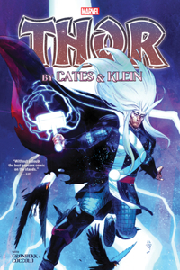](https://www.bookswagon.com/book/thor-by-cates-klein-omnibus/9781302958541)

**Thor by Cates & Klein Omnibus**Nic Klein

No Review Yet

**₹6,930**

**35%**

[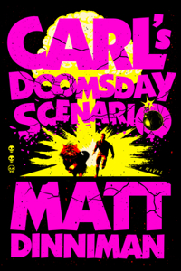](https://www.bookswagon.com/book/carls-doomsday-scenario-matt-dinniman/9780593820261)

**Carl's Doomsday Scenario**Matt Dinniman

No Review Yet

**₹1,930**

**33%**

[](https://www.bookswagon.com/book/great-menopause-myth-kristin-johnson/9780760388266)

**Great Menopause Myth**Kristin Johnson

No Review Yet

**₹1,457**

**26%**

[](https://www.bookswagon.com/book/albert-can-cook-albert-niazhvinski/9780744091267)

**Albert Can Cook**Albert Niazhvinski

No Review Yet

**₹1,479**

**30%**

[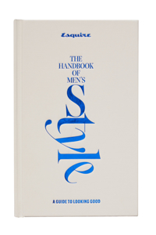](https://www.bookswagon.com/book/esquire-handbook-style-michael-b/9781958395806)

**Esquire The Handbook of Men's Style**Esquire

No Review Yet

**₹1,540**

**22%**

[](https://www.bookswagon.com/book/stillness-norm-architects/9783967041583)

**Stillness**Norm Architects

No Review Yet

**₹4,719**

**35%**

[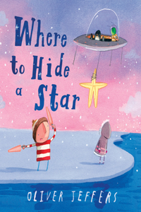](https://www.bookswagon.com/book/hide-a-star-oliver-jeffers/9780008579685)

**Where to Hide a Star**Oliver Jeffers

No Review Yet

**₹519**

**43%**

[](https://www.bookswagon.com/book/really-went-wrong--fawaz/9780300259575)

**What Really Went Wrong**Fawaz a Gerges

No Review Yet

**₹1,568**

**32%**

[](https://www.bookswagon.com/book/dolcegabbana-franco-colgni-muller-florence/9780847839773)

**Dolce & Gabbana: From the Heart to the Hands**Franco Colgni

No Review Yet

**₹2,693**

**27%**

[](https://www.bookswagon.com/book/sizzle-drizzle-nancy-birtwhistle/9781035044498)

**Sizzle & Drizzle: The Green Edition**Nancy Birtwhistle

No Review Yet

**₹1,364**

**34%**

[](https://www.bookswagon.com/book/well-plated-every-day-erin/9780593545300)

**Well Plated Every Day**Erin Clarke

No Review Yet

**₹2,033**

**30%**

[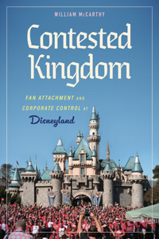](https://www.bookswagon.com/book/contested-kingdom-william-mccarthy/9781496854735)

**Contested Kingdom**William McCarthy

No Review Yet

**₹6,314**